Scam Guard

Final Year Project

Session 2020-2024

A project submitted in partial fulfillment of the degree of

BS in Computer Science



Department of Computer Science

Faculty of Computer Science & Information Technology

The Superior University, Lahore

Spring 2024

|  |  |  |  |  |  |
| --- | --- | --- | --- | --- | --- |
| Type (Nature of project) | | | [ ✓ ] **D**evelopment [ ] **R**esearch [ ] **R**&**D** | | |
| Area of specialization | | | Scrapper AI, Laravel | | |
| FYP ID | | | FYP-BCSM-F23-023 | | |
| **Project Group Members** | | | | | |
| Sr.# | Reg. # | Student Name | | Email ID | *Signature |
| (i) | Bcsm-F20-280 | Moiza Aleem | | [bcsm-f20-280@superior.edu.pk](mailto:bcsm-f20-280@superior.edu.pk) |  |
| (ii) | Bcsm-F20-297 | Muhammad Saarim | | [bcsm-f20-297@superior.edu.pk](mailto:bcsm-f20-297@superior.edu.pk) |  |
| (iii) | Bcsm-F20-259 | Hammad Aslam | | [bcsm-f20-259@superior.edu.pk](mailto:bcsm-f20-259@superior.edu.pk) |  |

*The candidates confirm that the work submitted is their own and appropriate credit has been given where reference has been made to work of others

# Plagiarism Free Certificate

This is to certify that, I Moiza Daughter of Muhammad Aleem, group leader of FYP under registration no Bcsm-F20-280 at Computer Science Department, The Superior College, Lahore. I declare that my FYP report is checked by my supervisor.

Date: 27-Nov-2023

Name of Group Leader: Moiza Aleem Signature: _____________

Name of Supervisor: Mam Amna Anjum Co-Supervisor: Mam Amna Anjum

Designation: Senior Lecturer Designation: Senior Lecturer

Signature: ________________ Signature: _________________

HoD: Dr. Arfan Jaffar

Signature: _______________

**Scam Guard**

**Change Record**

|  |  |  |  |  |
| --- | --- | --- | --- | --- |
| **Author(s)** | **Version** | **Date** | **Notes** | **Supervisor’s Signature** |
| Moiza |  | 26-05-2024 | Diagram Changings |  |
| Muhammad Saarim |  | 15-05-2024 | Changes in backend Code |  |
| Hammad Aslam |  | 09-04-2024 | Changes in scrapper AI Code |  |
| Hammad Aslam |  | 21-03-2024 | Testing and training model |  |
| Moiza |  | 18-03-2024 | Changes in use case diagram |  |
|  |  |  |  |  |
|  |  |  |  |  |
|  |  |  |  |  |
|  |  |  |  |  |
|  |  |  |  |  |

**APPROVAL**

|  |  |
| --- | --- |
| **Project Supervisor** | |
| Comments: ___________________________________________________________________ | | |
| _____________________________________________________________________________ | | |
| Name:______________________________ |  | |
| Date:_______________________________ | Signature:__________________________ | |

|  |  |
| --- | --- |
| **Project Manager** | |
| Comments: ___________________________________________________________________ | |
| _____________________________________________________________________________ | |
|  |  |
| Date:_______________________________ | Signature:__________________________ |

|  |  |
| --- | --- |
| **Head of the Department** | |
| Comments: ___________________________________________________________________ | |
| _____________________________________________________________________________ | |
|  |  |
| Date:_______________________________ | Signature:__________________________ |

# Dedication

*This proposal is dedicated to the pursuit of knowledge, innovation, and the relentless fight against digital deception.*

*To my family, whose unwavering support has been the bedrock of my academic journey. Your encouragement and understanding have fueled my determination to embark on this challenging endeavor.*

*To my professors and mentors, who have not only imparted knowledge but also inspired creativity and critical thinking. Your guidance has been invaluable in shaping the direction of this project.*

*To my friends and colleagues, who have shared the highs and lows of this academic adventure. Your camaraderie and shared passion for technological solutions have made the journey memorable.*

*And to the countless individuals who have fallen victim to digital scams, this proposal is a commitment to creating a tool that safeguards against exploitation. May "Scam Guard" contribute to a safer digital landscape, empowering users to navigate the virtual world with confidence.*

# 

# Acknowledgements

I would like to express my heartfelt gratitude to my supervisor, Mam Amna Anjum, for their unwavering support and mentorship throughout the development of the "Scam Guard" app proposal. Their expert guidance, insightful feedback, and encouragement have been indispensable in shaping the project.

Thank you for your dedication, patience, and the valuable lessons you've imparted. Your mentorship has been a source of inspiration, and I am grateful for the opportunity to learn under your guidance.

Thank you, Mam Amna Anjum, for being the foundation of my success.

# 

# Executive Summary

Due to the fast growth of usage of mobile devices, mobile apps are essential in day-to-day activities of most people. Ranking and identifying fraud is a critical challenge in front of the mobile App market because there are many mobile Apps. App developers are using delicate means more and more frequently for increasing their Apps sales or posting fake App ratings. So, it is necessary to prevent ranking fraud. This project introduces a system for mobile apps to rank fraud detection. The proposed method mines the leading sessions of mobile apps to precisely locate the ranking fraud. Furthermore, the system finds ranking, rating and review behaviors and investigation of three types of suggestion; they are, Ranking based suggestion, Rating based suggestion and Survey based suggestion.

Then, an aggregation method based on optimization to combine all the suggestion for fraud detection is proposed. The system measures App data collected from the App Store for an extended period.

# Table of Contents

Dedication iv

Acknowledgements v

Executive Summary vi

Table of Contents vii

List of Figures ix

List of Tables x

Chapter 1 1

Introduction 1

1.1. Background 2

1.2. Motivations and Challenges 2

1.3. Goals and Objectives 2

1.4. Literature Review/Existing Solutions 2

1.5. Gap Analysis 2

1.6. Proposed Solution 2

1.7. Project Plan 3

1.7.1. Work Breakdown Structure 3

1.7.2. Roles & Responsibility Matrix 3

1.7.3. Gantt Chart 3

1.8. Report Outline 3

Chapter 2 4

Software Requirement Specifications 4

2.1. Introduction 5

2.1.1. Purpose 5

2.1.2. Document Conventions 5

2.1.3. Intended Audience and Reading Suggestions 5

2.1.4. Product Scope 5

2.1.5. References 6

2.2. Overall Description 6

2.2.1. Product Perspective 6

2.2.2. Product Functions 6

2.2.3. User Classes and Characteristics 6

2.2.4. Operating Environment 7

2.2.5. Design and Implementation Constraints 7

2.2.6. User Documentation 7

2.2.7. Assumptions and Dependencies 7

2.3. External Interface Requirements 8

2.3.1. User Interfaces 8

2.3.2. Hardware Interfaces 8

2.3.3. Software Interfaces 8

2.3.4. Communications Interfaces 9

2.4. System Features 9

2.4.1. System Feature 1 9

2.4.1.1. Description and Priority 9

2.4.1.2. Stimulus/Response Sequences 9

2.4.1.3. Functional Requirements 9

2.4.2. System Feature 2 10

2.4.2.1. Description and Priority 10

2.4.2.2. Stimulus/Response Sequences 10

2.4.2.3. Functional Requirements 10

2.4.3. System Feature 3 (and so on) 11

2.5. Other Nonfunctional Requirements 11

2.5.1. Performance Requirements 11

2.5.2. Safety Requirements 11

2.5.3. Security Requirements 12

2.5.4. Software Quality Attributes 12

2.5.5. Business Rules 12

2.6. Other Requirements 12

Chapter 3 13

Use Case Analysis 13

3.1. Use Case Model 14

3.2. Use Case Descriptions 14

Chapter 4 15

System Design 15

4.1. Architecture Diagram 16

4.2. Domain Model 16

4.3. Entity Relationship Diagram with data dictionary 16

4.4. Class Diagram 17

4.5. Sequence / Collaboration Diagram 17

4.6. Operation contracts 17

4.7. Activity Diagram 18

4.8. State Transition Diagram 18

4.9. Component Diagram 18

4.10. Deployment Diagram 19

4.11. Data Flow diagram [only if structured approach is used - Level 0 and 1] 19

Chapter 5 20

Implementation 20

5.1. Important Flow Control/Pseudo codes 21

5.2. Components, Libraries, Web Services and stubs 21

5.3. Deployment Environment 21

5.4. Tools and Techniques 22

5.5. Best Practices / Coding Standards 22

5.6. Version Control 22

Chapter 6 23

Testing and Evaluation 23

6.1. Use Case Testing 24

6.2. Equivalence partitioning 24

6.3. Boundary value analysis 24

6.4. Data flow testing 24

6.5. Unit testing 25

6.6. Integration testing 25

6.7. Performance testing 25

6.8. Stress Testing 25

Chapter 7 26

Summary, Conclusion and Future Enhancements 26

7.1. Project Summary 27

7.2. Achievements and Improvements 27

7.3. Critical Review 27

7.4. Lessons Learnt 27

7.5. Future Enhancements/Recommendations 28

Appendices 29

Appendix A: User Manual 30

Appendix B: Administrator Manual 31

Appendix C: Information / Promotional Material 32

Reference and Bibliography 35

Index 37

# List of Figures

1.1 Work Breakdown Structure …………………………………………………………………….. 20

1.2 Gantt Chart ……………………………………………………………………………………………… 22

1.3 Empathy Map ………………………………………………………………………………………….. 24

1.4 External Interfaces

1.4.1 Home Page ………………………………………………………………………………………………. 40

1.4.2 About Section ………………………………………………………………………………………….. 40

1.4.3 Service Section …………………………………………………………………………………………. 42

1.4.4 Enrollment Section …………………………………………………………………………………… 42

1.4.5 Main Section ……………………………………………………………………………………………. 42

1.5 Use Case Model ……………………………………………………………………………………….. 59

1.6 Architecture Diagram ………………………………………………………………………………. 64

1.7 Domain Model …………………………………………………………………………………………. 65

1.8 Entity Relationship Diagram …………………………………………………………………….. 66

1.9 Class Diagram ………………………………………………………………………………………….. 67

1.10 Sequence Collaboration Diagram …………………………………………………………….. 67

1.11 Activity Diagram ………………………………………………………………………………………. 69

1.12 Component Diagram ………………………………………………………………………………… 70

1.13 Deployment Diagram ……………………………………………………………………………….. 70

1.14 Brochure …………………………………………………………………………………………………… 89

1.15 Flyer ………………………………………………………………………………………………………….. 90

1.16 Banner ………………………………………………………………………………………………………. 91

# List of Tables

1.1 Roles and Responsibility Matrix …………………………………………………………………………………. 21

# 

# Chapter 1

# Introduction

**Chapter 1:** Introduction

This project aims to develop a novel algorithm for practical detection of fraudulent mobile apps, addressing the rising number of apps in the market. By analyzing historical ranking records, the system identifies distinct ranking patterns during leading sessions, distinguishing fraudulent apps from regular ones. Three functions are devised for detecting ranking-based fraud suggestions, and two fraud recommendation categories are proposed based on app rating and review history. The approach involves an innovative process: rating-based suggestions, review-based suggestions, and ranking-based suggestions are identified before aggregation for comprehensive fraud detection. The key modules encompass rating, review preprocessing, and the aggregation method. Using RapidMiner, the system employs data mining and sentiment analysis for efficient fraud identification. This methodology offers significant benefits in preventing fraudulent apps from infiltrating the market.

## Background

The proliferation of mobile applications in recent years has brought about an urgent need for robust systems to detect and combat fraudulent apps infiltrating the market. With the increasing volume of mobile apps, the potential for malicious activities such as ranking fraud has become a significant concern. This project addresses this pressing issue by proposing a novel algorithm that focuses on the analysis of historical ranking records. Recognizing that fraudulent apps exhibit distinct ranking patterns during their leading sessions compared to legitimate ones, the system aims to develop practical methods for identification. By integrating insights from rating, review, and ranking behaviors, this project pioneers a comprehensive approach to fraud detection, promising considerable benefits in enhancing the security and integrity of the mobile app ecosystem. The utilization of advanced techniques, including data mining and sentiment analysis through tools like RapidMiner, positions this research at the forefront of innovative strategies to safeguard users and the mobile app market from fraudulent activities.

## Motivations and Challenges

**Motivation:**

The motivation behind this project stems from the critical need to safeguard users and the mobile app market from the escalating threat of fraudulent applications. As the mobile app landscape expands rapidly, the potential for malicious activities such as ranking fraud poses a significant risk to both consumers and developers. By developing an advanced algorithm that analyzes historical ranking records and detects subtle patterns indicative of fraudulent behavior, this project aims to contribute proactively to the ongoing battle against digital deception. The motivation is rooted in the desire to create a robust system that empowers users, app stores, and developers with tools to identify and mitigate the impact of fraudulent apps, fostering a more secure and trustworthy mobile app ecosystem.

**Challenges:**

Several challenges accompany the development of a comprehensive fraud detection system for mobile apps. One of the primary challenges is the dynamic nature of fraudulent activities, requiring the algorithm to adapt continuously to evolving tactics employed by malicious actors. The diversity in ranking behaviors and the sheer volume of app data present additional complexities in accurately distinguishing fraudulent patterns from legitimate ones. Additionally, the integration of rating, review, and ranking-based suggestions necessitates a sophisticated approach to ensure the reliability and efficiency of the detection system. Overcoming these challenges demands a combination of innovative algorithm design, robust data preprocessing techniques, and the utilization of advanced tools like RapidMiner, underscoring the intricate nature of addressing fraud in the ever-evolving landscape of mobile applications.

## Goals and Objectives

The primary goal of this project is to develop a cutting-edge fraud detection system for mobile applications, specifically targeting the rising threat of fraudulent activities such as ranking manipulation. The overarching aim is to enhance the security and integrity of the mobile app ecosystem by providing a robust tool that effectively identifies and mitigates the impact of fraudulent apps.

The specific objectives include:

**Algorithm Development:** Designing an innovative algorithm that analyzes historical ranking records to identify distinct patterns indicative of fraudulent behavior during leading sessions of mobile applications.

**Fraud Suggestion Classification:** Creating three distinct modules for fraud suggestion identification, focusing on rating-based suggestions, review-based suggestions, and ranking-based suggestions. Each module contributes valuable insights to comprehensively detect fraudulent activities.

**Aggregation Method:** Developing a sophisticated aggregation method that combines suggestions from the three modules to provide a holistic and accurate identification of fraudulent apps. This method aims to enhance the overall efficacy of the fraud detection system.

**Preprocessing Techniques:** Implementing preprocessing techniques for ratings and reviews, including the categorization of ratings into worst, average, and best, as well as tokenization, stop word removal, and stemming for reviews. These techniques contribute to refining the input data for improved accuracy in fraud detection.

**Integration with RapidMiner:** Leveraging the capabilities of RapidMiner to implement data mining and sentiment analysis, utilizing these advanced tools to enhance the efficiency of fraud identification and provide a user-friendly interface for stakeholders.

By achieving these objectives, this project aspires to introduce a groundbreaking fraud detection system that not only addresses the current challenges in the mobile app landscape but also sets the stage for proactive and adaptive solutions to future threats, ensuring a safer and more trustworthy environment for mobile app users and developers alike.

## Literature Review/Existing Solutions

1. **Web of Trust (WOT)**

It is a browser extension that provides users information about the website or app based on user-generated reviews and ratings.

1. **Virus Total**

Web-based service that analyzes files and URLs for potential threats. Users can upload APK files for scanning. Basically, for scanning viruses in app.

1. **Experian Cross Core**

Platform that provides fraud detection and identity verification services. Offers real-time decision taking, integration with third-party data sources, and customizable rules for fraud detection.

1. **SAS**

Offers a comprehensive fraud detection and prevention solution that combines machine learning, real-time monitoring, and rule-based systems.

## Gap Analysis

The current landscape of mobile app security reveals a substantial gap in effective fraud detection systems, necessitating the development of a comprehensive solution. Existing methods often lack sophistication in analyzing historical ranking records, leading to challenges in distinguishing fraudulent patterns from legitimate ones. There is a notable gap in the integration of diverse suggestions from rating, review, and ranking-based modules, highlighting the need for a more holistic approach to fraud detection.

Furthermore, the absence of advanced preprocessing techniques for ratings and reviews leaves room for inaccuracies in fraud identification. The dynamic nature of fraudulent activities presents a considerable challenge, emphasizing the necessity for an adaptive algorithm capable of keeping pace with evolving tactics. While some tools address certain aspects of fraud detection, the lack of a unified and user-friendly system, integrated with cutting-edge technologies like RapidMiner for data mining and sentiment analysis, represents a significant gap in the current state of mobile app security.

This project aims to bridge these gaps by introducing a novel algorithm, incorporating sophisticated modules, and utilizing advanced tools, thereby offering a more effective, adaptive, and comprehensive solution to the challenges posed by fraudulent activities in the mobile app ecosystem.

## Proposed Solution

This project represents the new novel approach for the development of a ranking fraud detection system for mobile apps. Initially, identification of rating-based suggestion is done. Then identification of review-based suggestions then by leading mining sessions ranking fraud suggestion is collected. And finally, the system performs the aggregation of all three suggestions to detect fraud apps. This method will offer considerable benefits and provides an opportunity to prevent fraudulent apps in the market. The important modules include,

* Rating Based Suggestions
* Review Based Suggestions
* Ranking Based Suggestions
* Aggregation of Suggestions

## Project Plan

We are designing a platform that will detect fraud apps based on reviews, ratings, rankings and aggregation. Firstly, Saarim, Hammad and Moiza will gather the requirements from different resources within 10 days. In this process we will gather following perspectives including:

* Project objectives and outcomes
* What tools would be required for it.
* What will be the functional and non-functional requirements?

and many other perspectives. Then we will move towards the analysis state which will be carried out by Moiza. It would include requirements overview, feasibility study, algorithm selection, data analysis, security, and performance analysis etc. It will be carried out in 5 days. The next step would be architecture, carried out in 7 days by Hammad in which he will design a rough design of project. Then will come the designing stage in which the rough design will be used and will get polished. It will be completed in 10 days by Saarim. Now, the most important part of the project will be performed, implementation and development. This will include the development of an application/website the user will use to get our services. It will take 90 days to complete and will be carried out by Saarim and Hammad. Once the project is developed and implemented, final testing would be done before presenting it so that any of the left weakness would be identified within 6 days by Moiza. Lastly, the documentation will be prepared for our project by Moiza in 7 days.

## Work Breakdown Structure

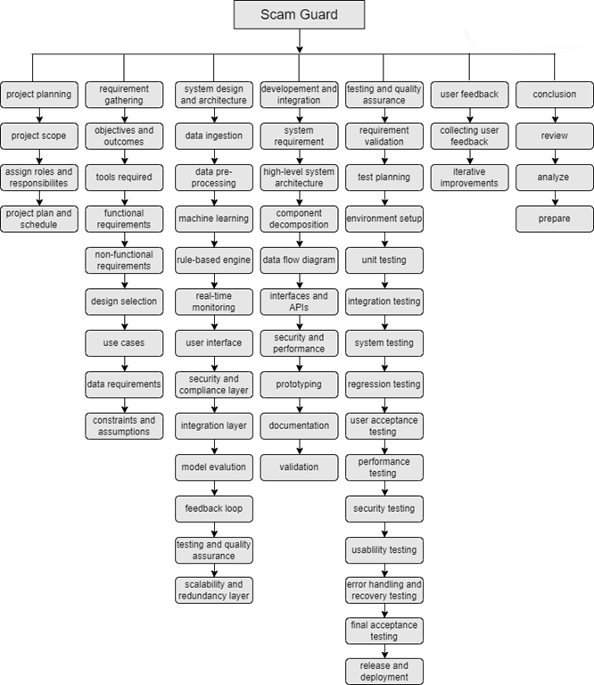

Figure 1: Work Breakdown Structure

## Roles & Responsibility Matrix

Table 1: Roles and Responsibility Matrix

|  |  |  |  |  |  |
| --- | --- | --- | --- | --- | --- |
| **WBS #** | **WBS Deliverable** | **Activity #** | **Activity to Complete the Deliverable** | **Duration**  **(# of Days)** | **Responsible Team Member(s) & Role(s)** |
| 1 | Requirement Gathering | 1 |  | 10 days | Saarim, Hammad, Moiza |
| 2 | Analysis | 2 |  | 5 days | Moiza |
| 3 | Architecture | 3 |  | 7 days | Hammad |
| 4 | Designing | 4 |  | 10 days | Saarim |
| 5 | Development & Implementation | 5 |  | 90 days | Saarim, Hammad |
| 6 | Final Testing | 6 |  | 6 days | Moiza |
| 7 | Documentation | 7 |  | 7 days | Moiza |

## Gantt Chart

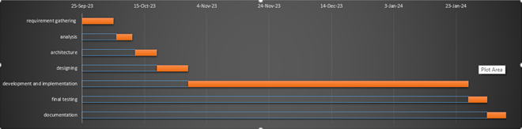

Figure 2: Gantt Chart

## Report Outline

1. **Introduction**
2. Background
3. Motivation
4. Challenges
5. Goals and Objectives
6. **Literature Review**
7. Overview of Mobile App Security
8. Existing Fraud Detection Systems
9. Limitations and Gaps in Current Approaches
10. **Methodology**
11. Algorithm Development
12. Rating-Based Suggestions Module
13. Review-Based Suggestions Module
14. Ranking-Based Suggestions Module
15. Aggregation Method
16. Preprocessing Techniques
17. Integration with RapidMiner
18. **Results and Analysis**
19. Performance Evaluation Metrics
20. Comparative Analysis with Existing Systems
21. Case Studies and Use Cases
22. **Discussion**
23. Implications of Findings
24. Addressing Challenges
25. Future Enhancements and Adaptations
26. **Conclusion**
27. Summary of Achievements
28. Contribution to Mobile App Security
29. Closing Remarks
30. **References**
31. **Appendices**
32. Code Snippets
33. Data Sets Used
34. Additional Visualizations

## Empathy Map

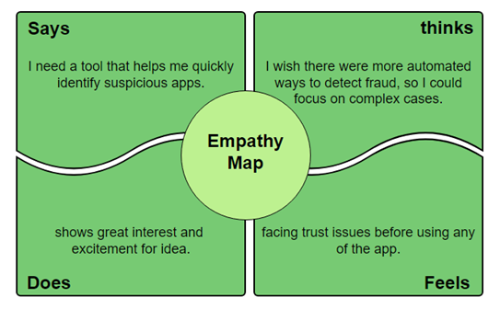

Figure 3: Empathy Map

# Chapter 2

# Software Requirement Specifications



## Introduction

## Purpose

## The purpose of this Software Requirements Specification (SRS) is to provide a detailed and comprehensive outline of the "Scam Guard" mobile app fraud detection system. This document serves as a critical foundation for the development team, stakeholders, and users by defining the

## functional and non-functional requirements, constraints, and specifications of the software. The primary objectives of this SRS are:

## Define System Scope: Clearly delineate the boundaries and scope of the "Scam Guard" application, outlining its intended functionalities and features.

## Detail Functional Requirements: Provide a detailed breakdown of the specific functions and capabilities the software must possess, including algorithm development, rating-based suggestions, review-based suggestions, ranking-based suggestions, and the aggregation method.

## Specify Non-functional Requirements: Outline the performance, security, usability, and other non-functional aspects expected of the system, ensuring a comprehensive understanding of its operational characteristics.

## Set Quality Standards: Define the quality standards and criteria against which the success and effectiveness of the "Scam Guard" system will be measured.

## Establish System Interfaces: Identify the external systems, databases, and tools with which the "Scam Guard" application will interact, ensuring seamless integration.

## Clarify User Requirements: Clearly articulate the needs and expectations of end-users, including any specific functionalities, user interfaces, and performance expectations.

## Provide a Basis for Testing: Serve as a foundation for the development of test cases, scenarios, and acceptance criteria to validate the functionality and performance of the "Scam Guard" system.

## Support Project Management: Aid project managers in estimating resource requirements, timelines, and potential risks associated with the development and deployment of the software.

## Facilitate Communication: Serve as a communication tool between developers, designers, testers, and stakeholders, ensuring a shared understanding of the software's goals and functionalities.

## Enable Future Enhancements: Lay the groundwork for future improvements, upgrades, and adaptations by providing a comprehensive understanding of the initial software requirements.

## In essence, this SRS acts as a blueprint for the "Scam Guard" project, guiding its development, testing, and deployment processes while aligning the efforts of the project team with the expectations and needs of stakeholders and end-users.

## Document Conventions

## Title Page:

## Document Title: Software Requirements Specification for "Scam Guard" Fraud Detection System

## Date: 27-Nov-23

## Table of Contents:

## Comprehensive listing of sections and subsections with page numbers.

## Introduction:

## Brief overview of the document's purpose and context.

## System Overview:

## Definition of the "Scam Guard" application, including its scope and key functionalities.

## Functional Requirements:

## Detailed breakdown of functional components, including algorithm development, rating-based suggestions, review-based suggestions, ranking-based suggestions, and the aggregation method.

## Use case scenarios and flow diagrams.

## Non-functional Requirements:

## Performance, security, usability, and other non-functional aspects.

## Quality standards and criteria.

## System Interfaces:

## Identification and description of external systems, databases, and tools interacting with "Scam Guard."

## User Requirements:

## Clear articulation of end-user needs, including specific functionalities, user interfaces, and performance expectations.

## Testing and Validation:

## Basis for testing, including test cases, scenarios, and acceptance criteria.

## Project Management:

## Resource requirements, timelines, and potential risks associated with the development and deployment of "Scam Guard."

## Future Enhancements:

## Considerations and recommendations for future improvements, upgrades, and adaptations.

## Communication Protocol:

## Guidelines for communication between team members, stakeholders, and end-users.

## Document Revision History:

## Record of changes made to the document, including version numbers, dates, and descriptions of modifications.

## Appendices:

## Additional information such as code snippets, datasets, and visualizations.

## References:

## Citations and sources referred to in the document.

## Note: Throughout the document, consistent formatting, font styles, and terminology will be used for clarity and uniformity. Use of diagrams, charts, and tables will enhance comprehension.

## Intended Audience and Reading Suggestions

**Intended Audience:**

1. **Development Team:**

* Software developers and programmers involved in the design and implementation of the "Scam Guard" fraud detection system.

1. **Testing Team:**

* Quality assurance and testing professionals responsible for validating the functionality and performance of the software.

1. **Project Managers:**

* Individuals overseeing the development and deployment of the "Scam Guard" application, responsible for resource allocation and timeline management.

1. **Stakeholders:**

* Business stakeholders, including executives and investors, are seeking a comprehensive understanding of the project's requirements, scope, and expected outcomes.

1. **User Experience Designers:**

* Design professionals responsible for creating user interfaces and ensuring a positive user experience.

1. **System Analysts:**

* Professionals analyze and interpret system requirements to ensure alignment with organizational goals and objectives.

1. **Future Developers/Enhancers:**

* Individuals who may be involved in future updates, enhancements, or adaptations of the "Scam Guard" system.

**Reading Suggestions:**

1. **Start with the Introduction:**

* Begin by reading the introduction to understand the purpose and context of the document.

1. **System Overview:**

* Gain a broad understanding of the "Scam Guard" application by reviewing the system overview section.

1. **Functional Requirements:**

* Delve into the functional requirements section to understand the specific features and capabilities of the system.

1. **Non-functional Requirements:**

* Explore the non-functional requirements section to grasp performance, security, and usability expectations.

1. **System Interfaces:**

* Review the system interfaces section to understand how "Scam Guard" interacts with external systems.

1. **User Requirements:**

* Gain insights into the expectations of end-users by reading the user requirements section.

1. **Testing and Validation:**

* Understand the basis for testing and validation by reviewing the relevant section.

1. **Project Management:**

* Learn about resource requirements, timelines, and potential risks by exploring the project management section.

1. **Future Enhancements:**

* Consider the recommendations and considerations for future improvements and adaptations.

1. **Appendices:**

* Refer to appendices for additional technical details, code snippets, datasets, and visualizations.

By following this reading sequence, the intended audience can gain a comprehensive understanding of the "Scam Guard" Software Requirements Specification, facilitating effective collaboration and successful project development.

## Product Scope

The scope of a fraud app detection project encompasses the development and implementation of a comprehensive system designed to identify and prevent fraudulent activities within mobile or web applications. This multifaceted undertaking involves the collection and preprocessing of data from various sources, the engineering of relevant features, and the deployment of machine learning models and rule-based systems to detect suspicious behavior in real-time. The project extends to the creation of user-friendly interfaces, robust security measures, and compliance with data protection regulations. Integration with existing systems and continuous model evaluation and retraining are integral components, as is the provision of training and support resources for users. The project's aim is to safeguard financial assets, protect user data, and maintain trust in an increasingly digital world, with the scope varying according to the industry, data sources, and specific goals.

## References

<https://www.academia.edu/download/64601134/Shivani%20Bandodkar%20-%20V8I8-0028.pdf>

<https://www.irjmets.com/uploadedfiles/paper/volume3/issue_6_june_2021/11950/1628083482.pdf>

<https://www.irjmets.com/uploadedfiles/paper/issue_10_october_2023/45489/final/fin_irjmets1698427928.pdf>

## Overall Description

## Product Perspective

The "Scam Guard" fraud detection system for mobile applications exists within a broader technological ecosystem and interfaces with various entities. Understanding its product perspective involves considering how it fits into this larger context.

**System Context:**

"Scam Guard" operates within the context of the mobile application market, interfacing app stores, mobile devices, and user interfaces. It is a component of the larger cybersecurity landscape.

**Interfaces:**

Interfaces with external systems, databases, and tools, such as integration with RapidMiner for data mining and sentiment analysis. These interfaces ensure seamless data exchange and analysis.

**User Interaction:**

Provides a user-friendly interface for both administrators (system managers, analysts) and end-users (mobile app developers, consumers) to interact with the fraud detection functionalities.

**Integration Points:**

Integrates with mobile app platforms, leveraging historical ranking records, ratings, and reviews for analysis. It may also integrate with external databases to enhance its data mining capabilities.

**Dependencies:**

May depend on external data sources for continuous updates on app rankings, user ratings, and reviews. Additionally, dependencies on RapidMiner for advanced data analytics.

**Regulatory Compliance:**

Adheres to industry and legal standards related to data privacy, user consent, and any other regulations pertinent to the mobile app and cybersecurity domains.

**Scalability:**

Designed to accommodate scalability considerations, capable of handling a growing volume of mobile apps and data points without compromising performance.

**Maintenance and Upgrades:**

Incorporates provisions for regular maintenance, updates, and upgrades to adapt to evolving fraud tactics, industry standards, and technological advancements.

**System Lifecycle:**

Encompasses all phases of the system lifecycle, from development and testing to deployment, monitoring, and potential decommissioning if necessary.

**Interoperability:**

Ensures interoperability with diverse mobile app environments, irrespective of the app's nature or functionalities.

## User Classes and Characteristics

1. **System Administrators:**

**Characteristics:**

* Technical expertise in system administration and cybersecurity.
* Responsible for configuring, maintaining, and updating the "Scam Guard" system.

**Roles:**

* System configuration, updates, and monitoring.
* User management and access control.

1. **Fraud Analysts:**

**Characteristics:**

* Strong analytical skills with a background in cybersecurity.
* Proficient in interpreting fraud patterns and making informed decisions.

**Roles:**

* Regularly analyze fraud suggestions generated by the system.
* Investigate and validate potential fraud cases.

1. **App Developers:**

**Characteristics:**

* Technical proficiency in app development.
* Concerned with ensuring the legitimacy of their apps and preventing false positives.

**Roles:**

* Access the system for insights into the ranking and behavior of their apps.
* Collaborate with fraud analysts if false positives are identified.

1. **App Users:**

**Characteristics:**

* General users of mobile apps with varying technical expertise.
* May have concerns about the security and legitimacy of the apps they download.

**Roles:**

* Benefit from the enhanced security provided by "Scam Guard" when using mobile apps.

1. **Data Scientists:**

**Characteristics:**

* Expertise in data analysis and machine learning.
* Involved in refining and enhancing the algorithm for fraud detection.

**Roles:**

* Collaborate with fraud analysts to improve the accuracy of fraud detection algorithms.

1. **Regulatory Compliance Officers:**

**Characteristics:**

* Familiarity with legal and industry standards in data protection.
* Ensure that "Scam Guard" adheres to relevant regulations.

**Roles:**

* Oversee compliance with data privacy laws and other relevant regulations.

1. **Customer Support Representatives:**

**Characteristics:**

* Strong communication and interpersonal skills.
* Assist users with inquiries, issues, or concerns related to the "Scam Guard" system.

**Roles:**

* Respond to user queries and provide support for any system-related issues.

## Operating Environment

The "Scam Guard" fraud detection system for mobile applications operates within a dynamic and interconnected environment. Understanding its operating environment is essential for ensuring compatibility, security, and optimal performance.

**Operating Systems:**

Compatible with major operating systems, including but not limited to Android, iOS, and other mobile operating platforms prevalent in the market.

**Web Browsers:**

Provides a web-based interface accessible through popular web browsers such as Google Chrome, Mozilla Firefox, Safari, and Microsoft Edge for system administrators and analysts.

**Programming Languages and Frameworks:**

Developed using programming languages commonly employed in web application development, such as Java, Python, React or JavaScript.

**Database Management Systems:**

Integrates with relational database management systems (RDBMS) such as MySQL, or SQLite for storing and managing data related to app rankings, reviews, and fraud suggestions.

**RapidMiner Integration:**

Compatible with RapidMiner, leveraging its data mining and sentiment analysis capabilities. Ensures seamless integration for enhanced fraud detection through advanced analytics.

**Network Protocols:**

Utilizes standard network protocols (e.g., HTTPS) to facilitate secure communication between system components, ensuring data integrity and confidentiality.

**Security Protocols:**

Implements robust security protocols, including encryption mechanisms (e.g., SSL/TLS) and secure authentication methods, to protect sensitive data and ensure system integrity.

**Mobile App Platforms:**

Interfaces with major mobile app platforms (e.g., Google Play Store, Apple App Store) to access real-time app rankings, reviews, and other relevant data for analysis.

**Compliance with Standards:**

Adheres to industry standards and regulatory requirements related to data privacy, ensuring compliance with laws, or any other relevant standards.

**Monitoring and Logging Tools:**

Integrates with monitoring and logging tools for tracking system performance, identifying potential issues, and facilitating troubleshooting.

## Design and Implementation Constraints

**Platform Compatibility:**

**Constraint:** The system must be designed to operate seamlessly on various mobile platforms (iOS, Android) and web browsers (Chrome, Firefox, Safari).

**Impact:** Ensures broad accessibility but requires careful consideration of platform-specific limitations and design considerations.

**Database Limitations:**

**Constraint:** The system relies on a relational database management system (RDBMS) for storing and managing app-related data.

**Impact:** The choice of RDBMS introduces constraints on scalability, requiring careful database optimization and potentially limiting the system's ability to handle massive datasets.

**RapidMiner Integration:**

**Constraint:** Integration with RapidMiner for data mining and sentiment analysis.

**Impact:** The system's design must accommodate compatibility with RapidMiner, potentially limiting flexibility in choosing alternative tools for advanced analytics.

**Security and Privacy Regulations:**

**Constraint:** Adherence to data privacy regulations imposes constraints on data handling and storage practices.

**Impact:** Requires careful design considerations to ensure compliance, potentially affecting the system's architecture and data processing workflows.

**Mobile App Platform APIs:**

**Constraint:** Reliance on APIs provided by mobile app platforms for accessing real-time app rankings and reviews.

**Impact:** The system's design must account for potential changes or limitations in these APIs, which may impact real-time data retrieval and analysis.

**Cloud Service Dependency:**

**Constraint:** The system is designed to operate in a cloud environment (e.g., AWS, Azure, Google Cloud).

**Impact:** Dependence on cloud services may introduce constraints related to service availability, pricing, and potential limitations imposed by the chosen cloud provider.

**Network Connectivity:**

**Constraint:** The system relies on internet connectivity for real-time data retrieval and interaction with external services.

**Impact:** Design must include mechanisms to handle scenarios of limited or intermittent network connectivity.

**Technology Stack:**

**Constraint:** Selection of specific programming languages (e.g., Java, Python).

**Impact:** Developers must adhere to the chosen technology stack, potentially limiting flexibility but ensuring a standardized and maintainable codebase.

**Scalability Considerations:**

**Constraint:** The system must be designed to handle a growing volume of mobile apps and data points.

**Impact:** Requires careful consideration of scalable architecture to accommodate future growth, potentially introducing complexity in design and implementation.

**Usability Constraints:**

**Constraint:** The user interface design must be intuitive for users with varying technical backgrounds.

**Impact:** Design constraints may limit certain interface elements, necessitating a balance between simplicity and functionality.

**Development Timeframe:**

**Constraint:** Project timelines and resource availability impose constraints on the development and implementation phases.

**Impact:** Design decisions must align with the project schedule, potentially influencing the depth of features and testing iterations.

Understanding and addressing these design and implementation constraints is crucial for ensuring the "Scam Guard" system's functionality, security, and adaptability within the specified operational context.

## Assumptions and Dependencies

**Assumptions:**

* **Stable APIs:** Assumes stability and availability of mobile app platform APIs for real-time data.
* **Internet Connectivity:** Assumes users have consistent internet access for data retrieval.
* **RapidMiner Availability:** Assumes continued availability and compatibility of RapidMiner.
* **Regulatory Stability:** Assumes regulatory stability in data privacy and cybersecurity.
* **User Cooperation:** Assumes cooperation of app developers in fraud investigations.
* **App Developer’s Interest:** Assumes app developer’s interest in accessing system insights.

**Dependencies:**

* **Mobile App Platform APIs:** System depends on stable and documented APIs for data retrieval.
* **RapidMiner Integration:** Integration with RapidMiner is critical for advanced analytics.
* **Cloud Service Availability:** System relies on cloud services for hosting and scalability.
* **Database Management System:** Dependent on the chosen RDBMS for data storage.
* **Internet Connectivity:** System requires consistent internet access for real-time interaction.
* **User Cooperation:** Effectiveness of fraud investigations depends on stakeholder cooperation.
* **Regulatory Compliance:** Compliance with data privacy regulations is a critical dependency.
* **Timely Updates:** System depends on timely updates from mobile app platforms for accuracy.

## External Interface Requirements

## 

## User Interfaces

**Home Page:**

The main page that will appear to the user will contain information about us.

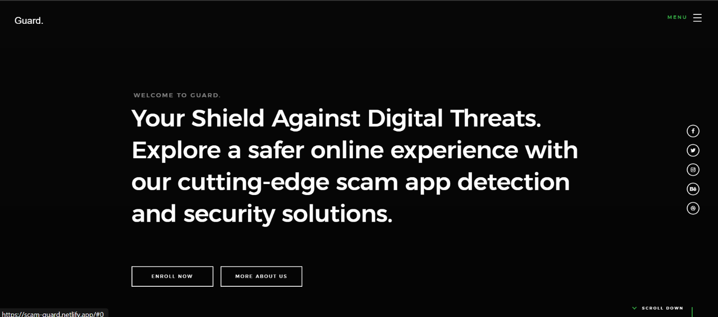

Figure 4: Home Page

**About Section:**

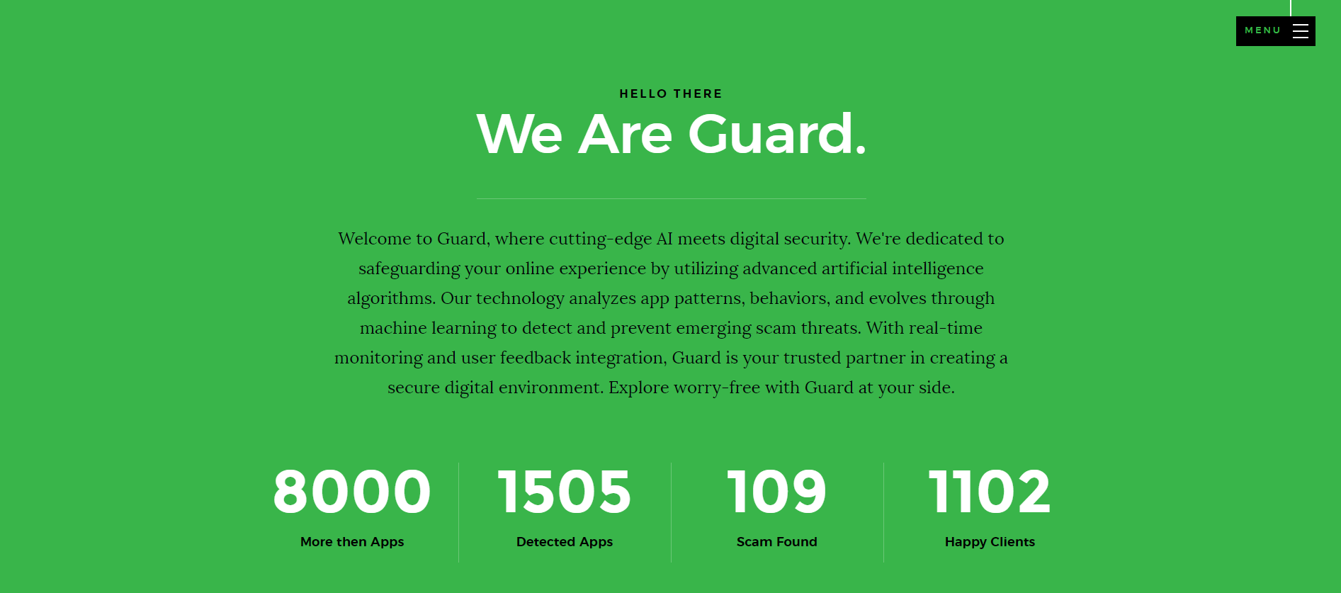

Figure 5: About Section

**Services Section:**

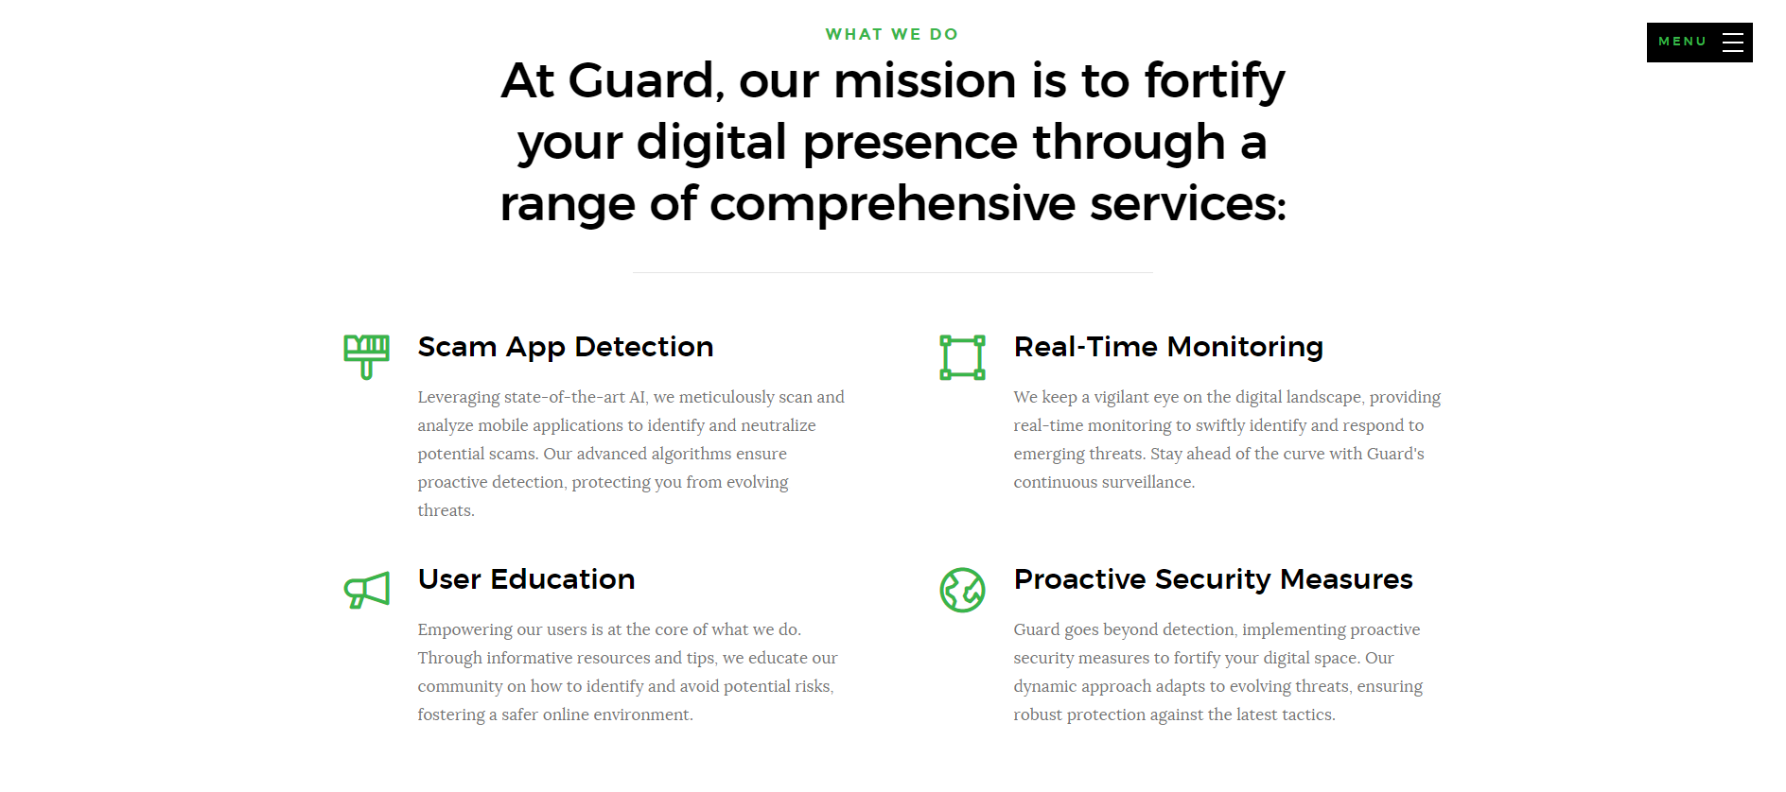

Figure 6: Services Section

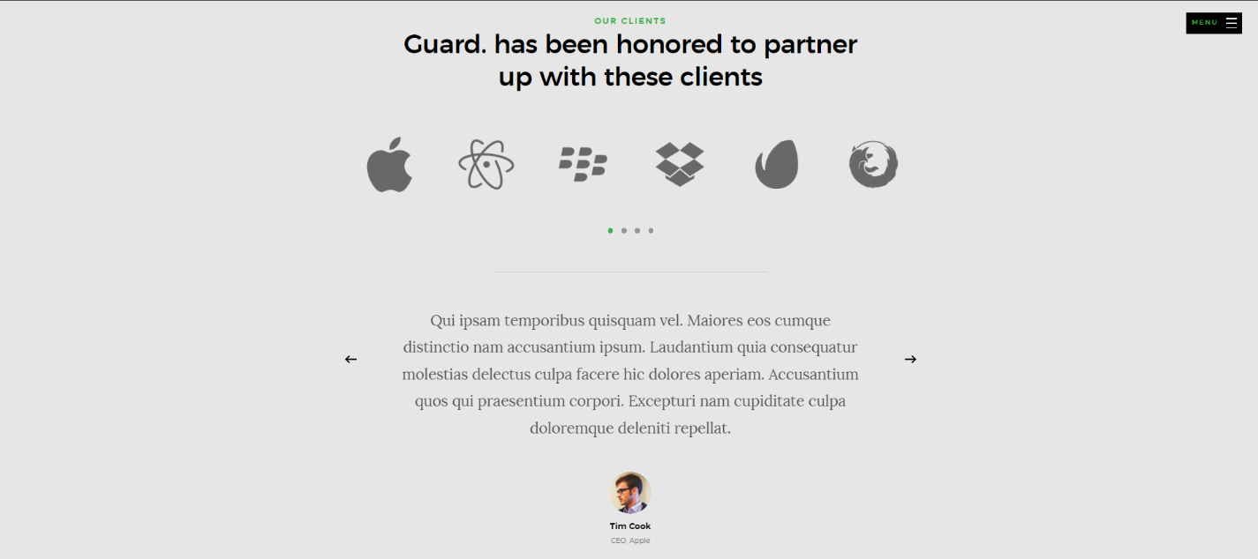

Figure 7: Services Section

**Enrollment Section:**

This is the section where the user will enter his/her Name, Email, Purpose and click on enroll now to continue further.

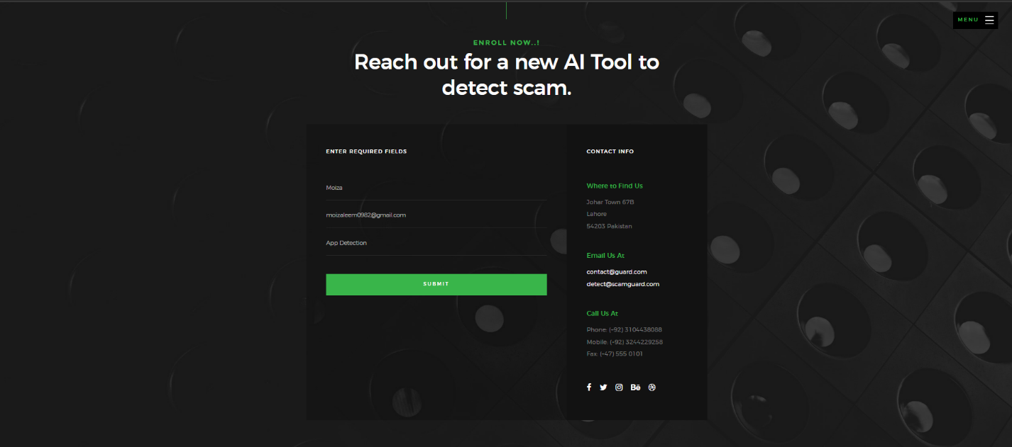

Figure 8: Enrollment Section

**Main Section:**

Where the user will enter the app link, name, and source and where it is from either google play store or IOS store etc. and it will show either that app is true or fake based on reviews.

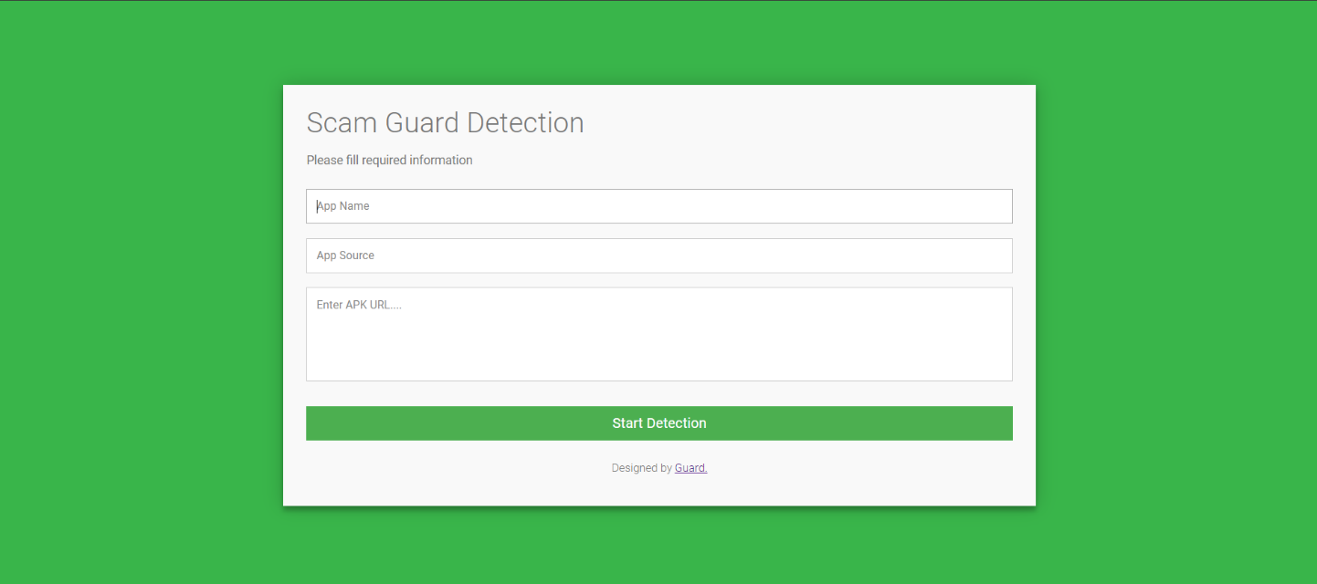

Figure 9: Main Section

**Help and Support Center:**

**Purpose:** Provides users with resources for assistance, FAQs, and contact information.

**Features:** Knowledge base, troubleshooting guides, and a ticketing system for support.

**Mobile-Friendly Interface:**

**Purpose:** Ensures a responsive and user-friendly experience on mobile devices.

**Features:** Optimized layouts, touch-friendly navigation, and app-specific insights for mobile users.

**Notification Center:**

**Purpose:** Alerts users and administrators about important system events, fraud alerts, and updates.

**Features:** Customizable notification preferences, real-time alerts, and history log.

## Hardware Interfaces

1. **Server Infrastructure:**

**Purpose:** Hosts the core components of the "Scam Guard" system.

**Interface Requirements:** Standard server hardware with sufficient processing power, memory, and storage to handle data processing and analysis.

1. **Network Infrastructure:**

**Purpose:** Facilitates communication between system components, external APIs, and cloud services.

**Interface Requirements:** Network hardware supporting standard protocols (e.g., TCP/IP, HTTPS) for secure and reliable data transfer.

1. **Mobile Devices:**

**Purpose:** Supports the mobile-friendly interface for users accessing the system on smartphones and tablets.

**Interface Requirements:** Compatibility with common mobile device specifications, ensuring a responsive and seamless user experience.

1. **Computing Devices for Administrators and Analysts:**

**Purpose:** Supports the desktop or laptop devices used by system administrators and fraud analysts.

**Interface Requirements:** Standard computing hardware with browsers compatible with the system's web-based interfaces.

1. **RapidMiner-Compatible System:**

**Purpose:** Supports the integration with RapidMiner for data mining and sentiment analysis.

**Interface Requirements:** Hardware that meets the system requirements for running RapidMiner, including sufficient CPU and memory resources.

1. **Database Server:**

**Purpose:** Manages the storage and retrieval of data in the chosen relational database management system (RDBMS).

**Interface Requirements:** Hardware specifications compatible with the requirements of the selected RDBMS.

1. **Cloud Infrastructure:**

**Purpose:** Hosts the system in a cloud environment for scalability and flexibility.

**Interface Requirements:** Compatible with the chosen cloud service provider (e.g., AWS, Azure, Google Cloud), meeting resource and security requirements.

1. **Printing and Scanning Devices:**

**Purpose:** Supports document-related tasks, such as generating reports or scanning documents related to fraud investigations.

**Interface Requirements:** Standard interfaces for connecting with printing and scanning devices, ensuring seamless document management.

1. **User Interaction Devices:**

**Purpose:** Supports various input devices for user interactions, such as keyboards, mice, and touchscreens.

**Interface Requirements:** Compatibility with standard input devices for navigating and interacting with the system interfaces.

1. **Notification Devices:**

**Purpose:** Sends notifications to users and administrators about important system events.

**Interface Requirements:** Compatibility with devices capable of receiving notifications, such as smartphones, tablets, or desktop computers.

## Software Interfaces

1. **Mobile App Platforms APIs:**

**Purpose:** Real-time access to app rankings and reviews.

**Requirements:** Integration with platform APIs, adherence to authentication mechanisms.

1. **RapidMiner Integration:**

**Purpose:** Advanced data mining and sentiment analysis.

**Requirements:** Interface with RapidMiner APIs, configuration for data inputs and analytics.

1. **Web Browsers:**

**Purpose:** Web-based user interface access.

**Requirements:** Compatibility with major browsers (Chrome, Firefox, Safari, Edge).

1. **Database Management System (DBMS):**

**Purpose:** Data storage and retrieval.

**Requirements:** Compatibility with chosen RDBMS (e.g., MySQL, PostgreSQL), SQL utilization.

1. **Cloud Service APIs:**

**Purpose:** Hosting and scalability.

**Requirements:** Adherence to APIs of chosen cloud provider (e.g., AWS, Azure).

1. **Operating Systems:**

**Purpose:** Compatibility with various OS.

**Requirements:** Support for mobile (Android, iOS) and server-side OS (Linux, Windows).

1. **RapidMiner-Compatible System:**

**Purpose:** Compatibility with RapidMiner deployment.

**Requirements:** Adherence to RapidMiner's system requirements.

1. **APIs for External Services:**

**Purpose:** Interaction with external services.

**Requirements:** Compliance with external service API specifications.

1. **Security Protocols:**

**Purpose:** Secure communication and data protection.

**Requirements:** Implementation of standard security protocols (e.g., HTTPS), encryption, and authentication.

1. **Development Frameworks:**

**Purpose:** Utilization of programming languages and frameworks.

**Requirements:** Adherence to chosen development stack (e.g., Java, Python, Django, Flask).

1. **Notification Services:**

**Purpose:** Timely notifications to users and administrators.

**Requirements:** Interface with notification services for reliable message delivery.

1. **Document Management Software:**

**Purpose:** Support for document-related tasks.

**Requirements:** Integration with document management software, compatibility with standard formats.

## Communications Interfaces

1. **HTTPS/TLS for Web Communication:**

**Purpose:** Secure communication between users and the web interface.

**Requirements:** Implementation of HTTPS/TLS protocols.

1. **RESTful APIs for Mobile App Platforms:**

**Purpose:** Fetch real-time app data from mobile app platforms.

**Requirements:** Implementation of RESTful APIs adhering to platform guidelines.

1. **Web Sockets for Real-Time Updates:**

**Purpose:** Facilitate low-latency real-time updates on the system interface.

**Requirements:** Implementation of WebSocket communication.

1. **APIs for External Services (Notifications):**

**Purpose:** Send notifications about important system events.

**Requirements:** Integration with external notification services using their APIs.

1. **APIs for Cloud Service Integration:**

**Purpose:** Interact with cloud services for hosting and scalability.

**Requirements:** Implementation of APIs for seamless interaction with cloud resources.

1. **SQL for Database Interaction:**

**Purpose:** Manage interaction with the chosen RDBMS for data storage and retrieval.

**Requirements:** Utilization of SQL queries for database operations.

1. **APIs for RapidMiner Integration:**

**Purpose:** Communicate with RapidMiner for data mining and sentiment analysis.

**Requirements:** Implementation of APIs for data exchange and analytics configuration.

1. **Communication with External Document Management Software:**

**Purpose:** Interact with document management software for report generation.

**Requirements:** Utilization of APIs or standard protocols for seamless document-related communication.

1. **Internal System Communication:**

**Purpose:** Facilitate communication between different modules and components within the system.

**Requirements:** Well-defined interfaces and protocols for internal communication.

1. **Mobile Device Communication:**

**Purpose:** Enable communication between the system and mobile devices for app developer access.

**Requirements:** Responsive web interfaces compatible with mobile browsers.

1. **Communication with External APIs (Third-Party Integrations):**

**Purpose:** Integrate external services, tools, or data sources.

**Requirements:** Implementation of APIs conforming to third-party integration specifications.

## System Features

The features that collectively empower the "Scam Guard" system to proactively detect and prevent fraudulent activities in the mobile app ecosystem, providing valuable insights to app developers and fraud analysts are as below.

## Real-Time App Monitoring

**Description:**

Continuous monitoring of app rankings, reviews, and user interactions in real-time to detect anomalies and patterns indicative of fraudulent activities.

**Priority:** High

**Stimulus/Response Sequences:**

**Stimulus:** New app ranking or review data.

**Response:** Real-time analysis and, if necessary, triggering of fraud detection algorithms.

**Functional Requirements:**

**FR1:** Receive and process real-time app ranking and review data.

**FR2:** Implement algorithms to detect anomalies in ranking patterns.

**FR3:** Provide instant alerts for suspicious activities.

## Fraud Suggestions Dashboard

**Description:**

A centralized dashboard for fraud analysts to review and investigate flagged apps, consolidating information on potential fraud cases.

**Priority:** High

**Stimulus/Response Sequences:**

**Stimulus:** Detection of potential fraud.

**Response:** Display detailed information on the dashboard for analyst review.

**Functional Requirements:**

**FR1:** Display a list of flagged apps and associated details.

**FR2:** Provide filtering and sorting options for efficient investigation.

**FR3:** Allow analysts to mark cases as investigated or escalate for further action.

## Developer Insights Portal

**Description:**

A portal enabling app developers to access insights into the rankings and behavior of their apps, fostering transparency and collaboration.

**Priority:** Medium

**Stimulus/Response Sequences:**

**Stimulus:** Developer login.

**Response:** Display app-specific analytics, ranking history, and potential fraud alerts.

**Functional Requirements:**

**FR1:** Authenticate developers securely.

**FR2:** Display historical app rankings and user interactions.

**FR3:** Notify developers of any fraud-related suggestions.

## Advanced Analytics with RapidMiner

**Description:**

Integration with RapidMiner for advanced data mining and sentiment analysis to identify complex fraud patterns beyond standard algorithms.

**Priority:** High

**Stimulus/Response Sequences:**

**Stimulus:** Initiation of advanced fraud analysis.

**Response:** Utilize RapidMiner for in-depth data mining and sentiment analysis.

**Functional Requirements:**

**FR1:** Establish a secure connection with RapidMiner.

**FR2:** Define parameters for advanced analytics.

**FR3:** Receive and interpret results for further action.

## Rating-Based Fraud Detection

**Description:**

Algorithm to identify fraudulent apps based on unusual patterns in user ratings.

**Priority:** High

**Stimulus/Response Sequences:**

**Stimulus:** New user ratings.

**Response:** Apply rating-based fraud detection algorithm.

**Functional Requirements:**

**FR1:** Define criteria for suspicious rating patterns.

**FR2:** Analyze historical rating data for anomalies.

**FR3:** Generate fraud alerts for suspicious ratings.

## Review-Based Fraud Detection

**Description:**

Algorithm to identify fraudulent apps based on analysis of user reviews and sentiments.

**Priority:** High

**Stimulus/Response Sequences:**

**Stimulus:** New user reviews.

**Response:** Apply review-based fraud detection algorithm.

**Functional Requirements:**

**FR1:** Implement sentiment analysis for user reviews.

**FR2:** Identify patterns indicative of fraudulent reviews.

**FR3:** Trigger alerts for suspicious review activities.

## Ranking-Based Fraud Detection

**Description:**

Algorithm to detect fraud based on anomalies in the historical ranking patterns of apps.

**Priority:** High

**Stimulus/Response Sequences:**

**Stimulus:** Changes in historical ranking patterns.

**Response:** Apply ranking-based fraud detection algorithm.

**Functional Requirements:**

**FR1:** Analyze historical app ranking data.

**FR2:** Define criteria for suspicious ranking patterns.

**FR3:** Flag apps with anomalous ranking behavior.

## Aggregation of Fraud Suggestions

**Description:**

System module that aggregates fraud suggestions from rating, review, and ranking analyses.

**Priority:** Medium

**Stimulus/Response Sequences:**

**Stimulus:** Detection of potential fraud from different modules.

**Response:** Aggregate and present comprehensive fraud suggestions.

**Functional Requirements:**

**FR1:** Receive fraud suggestions from rating, review, and ranking modules.

**FR2:** Integrate and organize suggestions for analyst review.

**FR3:** Provide a unified report on potential fraud cases.

## Other Nonfunctional Requirements

## Performance Requirements

The "Scam Guard" Fraud Detection System imposes stringent performance requirements to ensure its effectiveness and responsiveness. It demands real-time data processing capabilities for timely fraud detection and scalability to accommodate the expanding volume of app data and user interactions without compromising performance. Swift response times, both in terms of system queries and notification delivery, are essential to maintain an efficient user experience. The system aims to support a specified number of concurrent users, execute fraud detection algorithms within acceptable time limits, and optimize data storage and retrieval speeds. High system uptime, responsive mobile interfaces, and efficient resource utilization contribute to overall user satisfaction and operational effectiveness. Continuous monitoring and optimization of the scalable cloud infrastructure are vital components to guarantee reliable performance under varying workloads. The "Scam Guard" system prioritizes the seamless execution of complex analytical tasks and rapid access to historical data to empower fraud analysts and developers in their roles.

## Safety Requirements

The "Scam Guard" Fraud Detection System incorporates safety requirements to ensure the secure and reliable operation of the platform. Data security measures are implemented to safeguard sensitive information, adhering to industry standards and regulations. The system employs encryption protocols to protect data transmission, ensuring the confidentiality and integrity of user and app-related information. Additionally, robust access controls and authentication mechanisms are implemented to prevent unauthorized access to the system, safeguarding against potential security breaches. Regular security audits and vulnerability assessments are conducted to identify and address potential threats proactively. In the event of system failures or unexpected incidents, the system is designed to have recovery mechanisms in place, allowing for the restoration of services and minimal data loss. Continuous monitoring for potential security risks and timely software updates contribute to the overall safety and resilience of the "Scam Guard" system, ensuring a secure environment for users, administrators, and developers.

## Security Requirements

The "Scam Guard" Fraud Detection System prioritizes robust security measures to safeguard against potential threats and ensure the integrity of sensitive information. Access to the system is tightly controlled through secure authentication processes, limiting entry to authorized personnel only. Data encryption protocols are employed to secure the transmission of information, protecting user data, app-related details, and analytical insights from unauthorized access or tampering. The system adheres to industry-standard security practices, regularly undergoing comprehensive security audits and assessments to identify and address vulnerabilities. User roles and permissions are finely tuned to restrict access based on specific responsibilities, reinforcing data confidentiality. To mitigate the impact of unforeseen events or system breaches, the platform incorporates backup and recovery mechanisms, allowing for the restoration of services and data integrity. The "Scam Guard" system prioritizes ongoing security monitoring, rapid response to emerging threats, and the prompt application of software updates to ensure a resilient and secure environment for all system stakeholders.

## Usability Requirements

The "Scam Guard" Fraud Detection System places a strong emphasis on usability to ensure an intuitive and efficient user experience. The user interfaces, including the dashboard for fraud analysts, developer insights portal, and real-time app monitoring, are designed with user-friendly navigation and clear information presentation. The system provides a responsive web interface that is accessible across various devices, ensuring flexibility for users such as administrators, analysts, and app developers. To enhance user adoption and facilitate quick task completion, the interfaces incorporate intuitive features such as filtering and sorting options in the fraud suggestions dashboard, enabling efficient investigation. The mobile-friendly interface is designed to be responsive, providing a seamless experience for users accessing the system on smartphones or tablets. The system also includes a comprehensive documentation and help center, offering resources and guides to aid users, administrators, and developers in understanding and utilizing system functionalities effectively. Usability testing is conducted regularly to gather user feedback and make iterative improvements, ensuring a user-centric design and contributing to the overall success of the "Scam Guard" system.

## Reliability Requirements

Reliability is a paramount concern for the "Scam Guard" Fraud Detection System, and as such, the platform is engineered to deliver consistent and dependable performance. The system is designed with a high degree of fault tolerance, ensuring continued functionality even in the face of unexpected errors or failures. To minimize the risk of data loss, regular automated backups of critical system data are conducted, providing a safety net for recovery in case of unforeseen incidents. The algorithms employed for fraud detection undergo rigorous testing and validation to enhance their accuracy and reduce the likelihood of false positives or negatives, contributing to the overall reliability of fraud detection outcomes. System updates and maintenance activities are strategically scheduled to minimize disruptions, and a robust version control system is implemented to rollback changes if needed. Continuous monitoring mechanisms are in place to promptly identify and address any deviations from expected system behavior. Reliability testing is conducted regularly to simulate various scenarios and ensure the system's stability and resilience under different conditions. The commitment to reliability in the "Scam Guard" system is foundational to its overall effectiveness and user trust.

## Maintainability/Supportability Requirements

Maintainability and supportability are integral aspects of the "Scam Guard" Fraud Detection System, aimed at ensuring the long-term sustainability and ease of management. The system is built with modular architecture, allowing for straightforward updates, enhancements, and the incorporation of new features. Codebase documentation is comprehensive and regularly updated, facilitating ease of understanding, and reducing the learning curve for developers involved in system maintenance. A version control system is implemented to track changes systematically, enabling efficient rollbacks if necessary. Continuous support and training programs are established to equip administrators, analysts, and developers with the necessary skills to manage and operate the system effectively. The system's interfaces are designed with user-friendly features, reducing the likelihood of errors and facilitating streamlined user interactions. In the event of system issues, a dedicated support team is in place to provide timely assistance, and a knowledge base is maintained to address common queries. Regular system health checks, automated diagnostic tools, and periodic performance assessments contribute to the overall maintainability and supportability of the "Scam Guard" system, ensuring its longevity and adaptability to evolving needs.

## Portability Requirements

Portability is a key consideration for the "Scam Guard" Fraud Detection System, ensuring flexibility in deployment and accessibility across various environments. The system is designed to be platform-agnostic, supporting deployment on diverse operating systems, including Linux and Windows, to accommodate different user preferences. Furthermore, the system's architecture is cloud-native, allowing seamless integration with major cloud service providers such as AWS, Azure, and Google Cloud. This ensures scalability, easy resource management, and adaptability to varying workloads. The web-based interfaces are responsive and compatible with major browsers like Chrome, Firefox, Safari, and Edge, providing users with consistent experiences across different devices. The system's mobile-friendly interface allows app developers and administrators to access functionalities on the go, enhancing overall accessibility. Clear and comprehensive installation guides and documentation further support straightforward deployment on different infrastructures. The "Scam Guard" system's commitment to portability ensures that it can be deployed in diverse environments, adapting to the preferences and requirements of its users.

## Efficiency Requirements

Efficiency is a core focus for the "Scam Guard" Fraud Detection System, with the goal of optimizing resource utilization and ensuring swift and accurate fraud detection processes. The system employs advanced algorithms, including those integrated with RapidMiner, designed for efficient data mining and sentiment analysis. These algorithms are optimized to execute within acceptable time frames, providing timely insights for fraud detection. The system's database operations, encompassing storage and retrieval of historical app data, are streamlined to maximize speed and responsiveness. Additionally, the utilization of scalable cloud infrastructure enhances overall efficiency, allowing the system to dynamically allocate resources based on demand, ensuring optimal performance during varying workloads. The real-time data processing capabilities of the system contribute to its efficiency, enabling prompt detection of suspicious activities. Continuous monitoring and optimization efforts are integral to the development process, ensuring that the "Scam Guard" system maintains high efficiency in handling complex analytical tasks, delivering rapid responses to user queries, and effectively scaling to meet the evolving demands of the mobile app ecosystem.

## Domain Requirements

The "Scam Guard" Fraud Detection System operates within the dynamic and complex domain of mobile app fraud detection. It necessitates a deep understanding of the mobile app ecosystem, encompassing various platforms like Google Play Store and Apple App Store. The system is designed to adapt to the ever-evolving landscape of mobile applications, accommodating changes in ranking algorithms, user behavior, and emerging fraud patterns. It requires access to real-time app ranking and review data to effectively identify anomalies and potentially fraudulent activities. Understanding the intricacies of user ratings, reviews, and historical ranking patterns is crucial for the system's fraud detection algorithms. Compliance with data protection regulations and industry standards within the mobile app domain is imperative to ensure user privacy and data security. The system's functionalities must align with the expectations and needs of app developers, fraud analysts, and administrators within the unique context of the mobile app fraud detection domain. Regular updates and close monitoring of industry trends are essential to adapt the system to emerging challenges and maintain its effectiveness within this specialized domain.

# Chapter 3

# Use Case Analysis

**Chapter 3:** Use Case Analysis

The use case analysis for the "Scam Guard" Fraud Detection System involves several key scenarios. Firstly, the system accommodates the need for fraud analysts to efficiently investigate flagged apps through a centralized fraud suggestions dashboard, streamlining the detection process. App developers benefit from a dedicated insights portal, gaining access to real-time rankings and behavioral insights for their apps. Real-time app monitoring provides analysts with immediate visibility into app rankings and reviews, enabling quick response to potentially fraudulent activities. The system ensures a responsive mobile interface, allowing developers and administrators to access critical information on-the-go. The aggregation of fraud suggestions from rating, review, and ranking analyses offers a comprehensive overview for analysts to make informed decisions. With advanced analytics integrated using RapidMiner, the system enhances fraud detection accuracy by identifying complex patterns beyond standard algorithms. Overall, the use case analysis highlights the system's versatility in addressing the needs of fraud analysts, app developers, and administrators within the context of mobile app fraud detection.

## Use Case Model

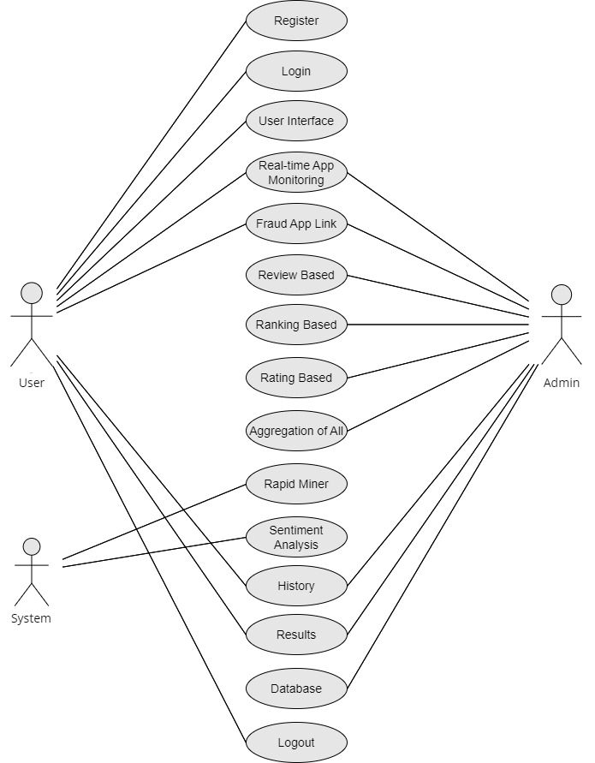

Figure 10: Use Case Model

## Use Cases Description

**Use Case ID: 1**

**Use Case Name:** Fraud Analyst Investigation

**Actors:** Fraud Analyst, System

**Description:**

**Precondition:** The system detects potentially fraudulent activities based on rating, review, or ranking analyses.

**Main Flow:**

* The Fraud Analyst logs into the system and accesses the centralized fraud suggestions dashboard.
* The dashboard displays a list of flagged apps with details such as anomalous rankings, suspicious reviews, and ratings patterns.
* The Fraud Analyst selects a flagged app to investigate further, accessing detailed information and historical data.
* Utilizing various filters and sorting options, the analyst efficiently navigates through the data to identify potentially fraudulent activities.
* If necessary, the analyst can escalate the case for further action or mark it as investigated.

**Postcondition:** The fraud analyst has reviewed and, if needed, acted on flagged apps, contributing to the overall fraud detection and prevention efforts.

**Use Case ID: 2**

**Use Case Name:** App Developer Insights

**Actors:** App Developer, System

**Description:**

**Precondition:** The app developer seeks insights into the performance and rankings of their app.

**Main Flow:**

* The App Developer logs into the system and navigates to the developer insights portal.
* The portal provides real-time information on the app's current rankings, user reviews, and historical performance data.
* The developer analyzes the insights to understand user engagement, identify areas for improvement, and ensure the legitimacy of app-related activities.

**Postcondition:** The app developer gains valuable insights into their app's performance, enabling informed decisions for app management and enhancement.

**Use Case ID: 3**

**Use Case Name:** Real-Time App Monitoring

**Actors:** System

**Description:**

**Precondition:** The system continuously monitors app rankings, reviews, and user interactions.

**Main Flow:**

* The system receives real-time app ranking and review data from various platforms.
* Using predefined algorithms, it analyzes the data for anomalies and potentially fraudulent activities.
* If suspicious patterns are detected, the system generates real-time alerts and notifications for further investigation.

**Postcondition:** The system ensures prompt detection and response to potentially fraudulent activities, contributing to proactive fraud prevention.

**Use Case ID: 4**

**Use Case Name:** Aggregation of Fraud Suggestions

**Actors:** System

**Description:**

**Precondition:** The system has received fraud suggestions from rating, review, and ranking analyses.

**Main Flow:**

* The system aggregates fraud suggestions from different modules, including rating-based, review-based, and ranking-based analyses.
* Using a predefined aggregation method, the system organizes and combines the suggestions into a unified report.
* The aggregated report provides a comprehensive overview of potentially fraudulent activities across different dimensions.
* Analysts can access this report through the fraud suggestions dashboard, gaining a holistic perspective on potential fraud cases.

**Postcondition:** The system delivers a consolidated and organized report of fraud suggestions, aiding fraud analysts in efficiently prioritizing and investigating potential fraudulent apps.

# Chapter 4

# System Design

**Chapter 4:** System Design

The system design for the "Scam Guard" Fraud Detection System involves a modular and scalable architecture. Utilizing a cloud-based infrastructure, the system employs Docker containers for seamless deployment and Kubernetes for efficient orchestration. A web application framework, such as Django or Spring Boot, facilitates the development of user-friendly interfaces. PostgreSQL and MongoDB serve as the database management systems for structured and unstructured data storage. Integration with RapidMiner enhances data mining capabilities, while external APIs from app stores enable real-time data retrieval. Security measures, including SSL certificates and encryption, safeguard sensitive data. Continuous integration and automated testing processes, alongside version control using Git, contribute to a streamlined development lifecycle. Monitoring tools like Prometheus and logging with the ELK Stack provide insights into system performance. This comprehensive system design ensures scalability, security, and efficiency in addressing the dynamic requirements of mobile app fraud detection.

## Architecture Diagram

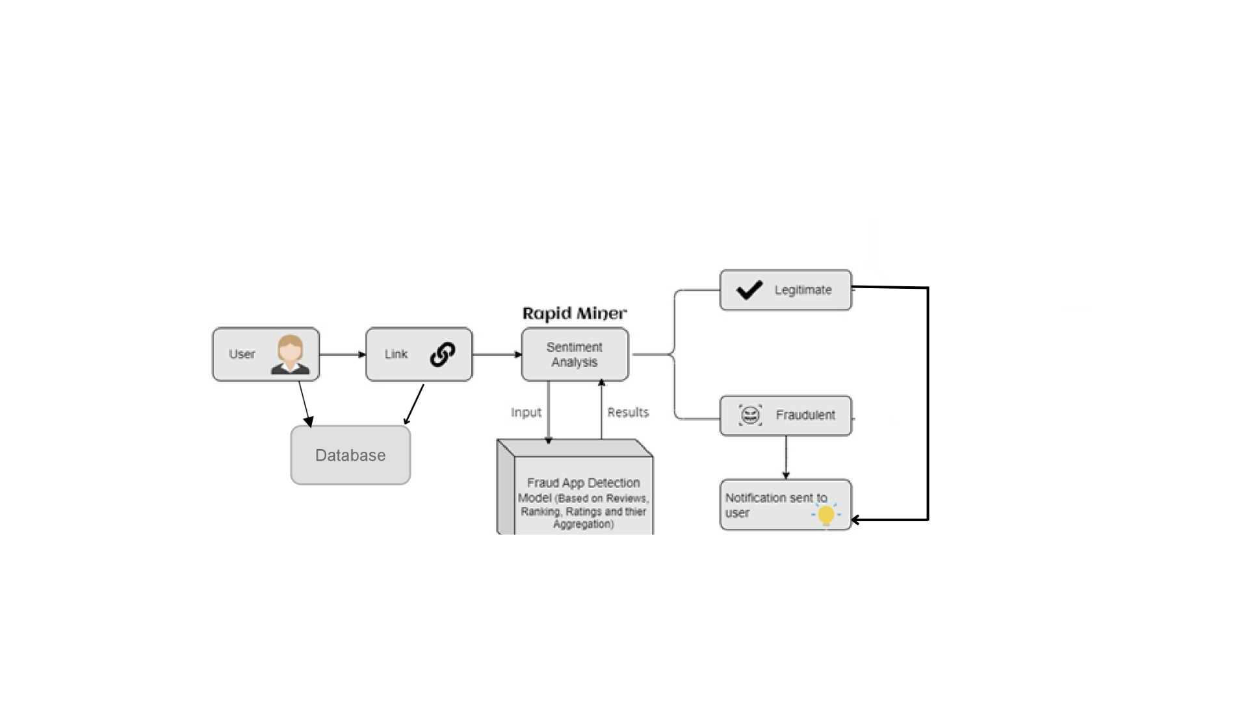

Figure 11: Architecture Diagram

## Domain Model

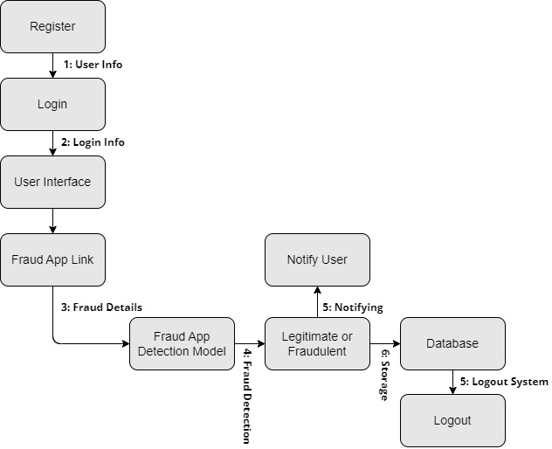

Figure 12: Domain Model

## Entity Relationship Diagram with data dictionary

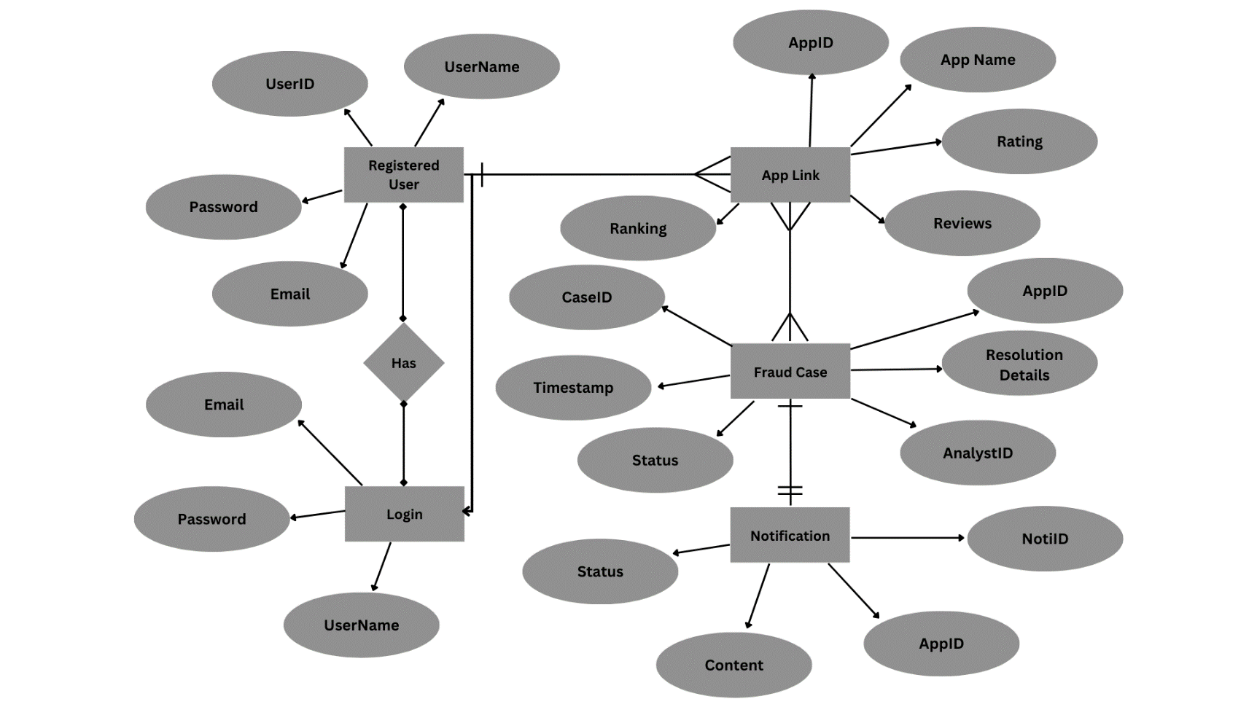

Figure 13: Entity Relationship Diagram

## Class Diagram

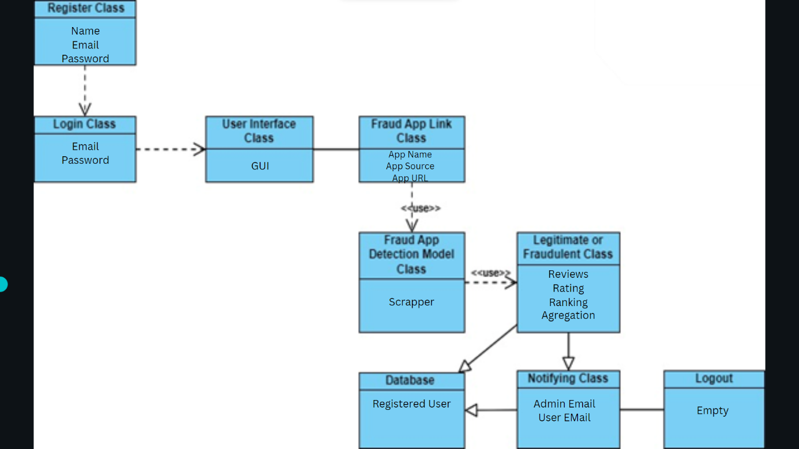

Figure 14: Class Diagram

## Sequence / Collaboration Diagram

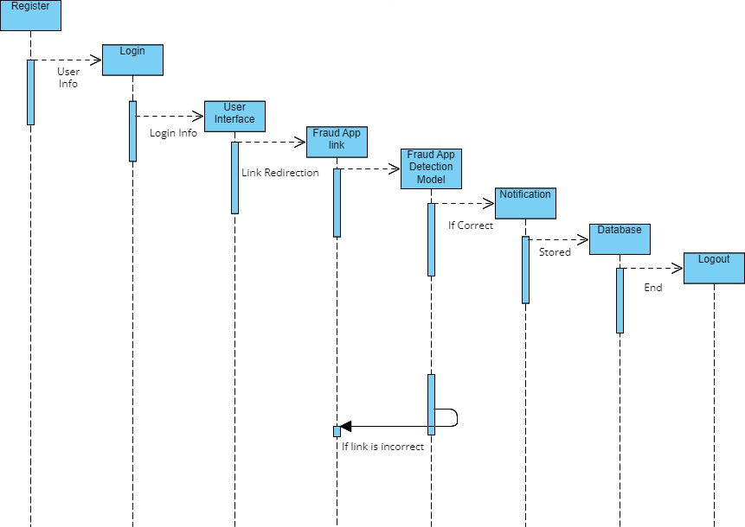

Figure 15: Sequence Diagram

## Operation contracts

**Operation Contract for Real-Time Data Fetcher:**

**Operation Name:** fetchRealTimeData()

**Preconditions:**

* The system has access to the external app store APIs.

**Postconditions:**

* The method returns real-time data for analysis.
* The returned data is in a structured format.
* Any errors during data fetching are appropriately handled.

**Operation Contract for Fraud Detection Algorithms:**

**Operation Name:** analyzeData(appData)

**Preconditions:**

* The input appData is valid and represents real-time app information.

**Postconditions:**

* The method returns fraud suggestions based on the analysis.
* The suggestions adhere to defined patterns of fraud detection.
* Appropriate error handling is implemented for unexpected scenarios.

**Operation Contract for Notification Component:**

**Operation Name:** notifyAnalysts(suspiciousApps)

**Preconditions:**

* The input suspiciousApps contains valid information about potentially fraudulent applications.

**Postconditions:**

* Notifications are sent to designated fraud analysts.
* The notification process is logged for auditing purposes.
* The system gracefully handles any errors during the notification process.

## Activity Diagram

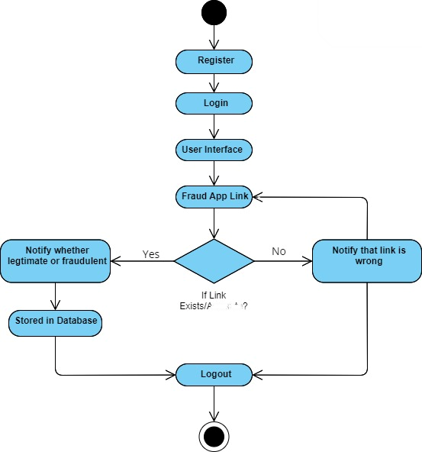

Figure 16: Activity Diagram

## Component Diagram

Figure 17: Component Diagram

## Deployment Diagram

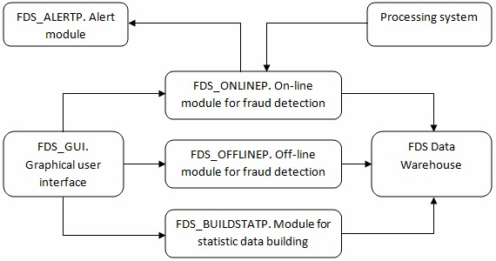

Figure 18: Deployment Diagram

# 

# Chapter 5

# Implementation

**Chapter 5:** Implementation

The implementation of the "Scam Guard" Fraud Detection System involves a multi-faceted approach, utilizing cutting-edge technologies and methodologies. The system is developed using a modular architecture, allowing for scalability and ease of updates. Advanced algorithms, including those integrated with RapidMiner, are implemented to execute efficient data mining and sentiment analysis for accurate fraud detection. The utilization of a robust database management system ensures optimal storage and retrieval of historical app data. The system's web-based interfaces are crafted using responsive design principles, guaranteeing a seamless user experience across devices. Cloud-native architecture enables flexible deployment on major cloud platforms, supporting scalability and resource optimization. Security measures, including encryption protocols and access controls, are rigorously implemented to protect sensitive data. Continuous integration and version control streamline the development process, while regular testing and quality assurance procedures ensure the reliability and efficiency of the implemented functionalities. The "Scam Guard" system is developed with a keen focus on usability, maintainability, and adherence to industry best practices for robust and effective implementation.

## Important Flow Control/Pseudo codes

Designing the flow control or pseudo code for a complex system like the "Scam Guard" Fraud Detection System involves breaking down the functionality into specific modules or components. Here, I'll provide a simplified example of pseudo code for the key functionality of real-time app monitoring. Please note that this is a conceptual example, and actual implementation details would depend on the specific technologies and programming languages used.

**Pseudo Code:**

# Pseudo Code for Real-Time App Monitoring

# Define the main monitoring function

def monitor_apps():

while True:

# Fetch real-time app data from external sources (e.g., APIs from app stores)

app_data = fetch_real_time_data()

# Analyze the app data using fraud detection algorithms

suspicious_apps = analyze_data(app_data)

# Notify fraud analysts if suspicious apps are detected

if suspicious_apps:

notify_analysts(suspicious_apps)

# Sleep for a defined interval before the next monitoring cycle

sleep(interval_time)

# Function to fetch real-time app data

def fetch_real_time_data():

# Implementation details for fetching data from external sources

# Function to analyze app data using fraud detection algorithms

def analyze_data(app_data):

# Implementation details for fraud detection algorithms

# Function to notify fraud analysts

def notify_analysts(suspicious_apps):

# Implementation details for notifying analysts

# Main function to start real-time monitoring

if __name__ == "__main__":

monitor_apps()

This pseudo code outlines the continuous monitoring process for real-time app data. It fetches data from external sources, analyzes it using fraud detection algorithms, and notifies fraud analysts if suspicious apps are detected. The system then repeats this process in a loop, allowing for ongoing real-time monitoring.

For specific modules like rating-based, review-based, and ranking-based fraud detection, similar pseudo code structures can be developed, tailoring the algorithms and logic to the unique requirements of each module. The actual implementation would involve integrating these modules into the overall system architecture.

## Components, Libraries, Web Services and stubs

**Components:**

**Real-Time Data Fetcher Component:**

**Responsibility:** Fetches real-time app data from external sources.

**Implementation:** Utilizes API calls or web scraping techniques to retrieve up-to-date information from app stores.

**Fraud Detection Algorithms Component:**

**Responsibility:** Implements rating-based, review-based, and ranking-based fraud detection algorithms.

**Implementation:** Incorporates machine learning models, sentiment analysis libraries, and custom algorithms for fraud detection.

**Notification Component:**

**Responsibility:** Sends notifications to fraud analysts when suspicious app activities are detected.

**Implementation:** Utilizes email services, messaging APIs, or custom notification systems for alerting analysts.

**User Interface Components:**

**Responsibility:** Provides user interfaces for fraud analysts, app developers, and administrators.

**Implementation:** Web-based interfaces using front-end frameworks like React or Angular, ensuring responsive design for different devices.

**Libraries:**

**RapidMiner Integration Library:**

**Responsibility:** Integrates the RapidMiner data mining and sentiment analysis tool into the system.

**Implementation:** Utilizes RapidMiner APIs or libraries for seamless integration.

**Database Access Library:**

**Responsibility:** Handles storage and retrieval of historical app data.

**Implementation:** Uses database connectors like SQL Alchemy (Python) or JDBC (Java) to interact with the database.

**Encryption Library:**

**Responsibility:** Ensures secure transmission and storage of sensitive data.

**Implementation:** Integrates encryption libraries like OpenSSL or Java Cryptography Architecture (JCA) for secure communication.

**Web Services:**

**Cloud Service Integration:**

**Responsibility:** Deploys the system on scalable cloud infrastructure.

**Implementation:** Utilizes services from AWS, Azure, or Google Cloud for hosting, storage, and resource management.

**External APIs for App Data:**

**Responsibility:** Fetches app data from external sources.

**Implementation:** Utilizes APIs provided by app stores such as Google Play Store API or Apple iTunes Connect API.

**Stubs:**

**Testing Stubs:**

**Responsibility:** Simulates external systems or components during testing.

**Implementation:** Develops stubs to mimic the behavior of external services or components, allowing for isolated testing.

**Notification Stub:**

**Responsibility:** Simulates the notification system during testing.

**Implementation:** Provides a stub for sending test notifications without triggering actual alerts.

These components, libraries, web services, and stubs collectively form the foundation of the "Scam Guard" Fraud Detection System, ensuring its functionality, security, and integration with external services. Actual implementations would depend on the chosen programming languages, frameworks, and technologies.

## Deployment Environment

The "Scam Guard" Fraud Detection System's deployment environment is built for scalability and reliability. Hosted on cloud infrastructure like AWS or Azure, the system employs Docker containers and Kubernetes orchestration for streamlined deployment and scalability. A web application framework such as Django or Spring Boot ensures user-friendly interfaces. PostgreSQL or MongoDB serves as the database management system for structured and unstructured data. Integration with RapidMiner Server enhances data mining capabilities. Security measures include SSL certificates, firewalls, and encryption for secure data handling. CI/CD tools automate testing and deployment processes. External APIs from Google Play Store and Apple iTunes Connect provide real-time data retrieval. Monitoring tools like Prometheus and logging with the ELK Stack offer insights into system performance. Overall, the deployment environment is designed to meet the dynamic needs of mobile app fraud detection, providing a secure, scalable, and efficient foundation.

## Tools and Techniques

**For User Interface:**

**Tools:** Visual Studio Code

**Technique:** Will design an interactive interface for the users to serve them from our services.

**For Fraud detection:**

**Tools:** Python, Rapid Miner, Sentiment Analysis

**Technique:** Will use these tools to detect the fraud.

## Best Practices / Coding Standards

Adhering to best practices and coding standards is integral for the "Scam Guard" Fraud Detection System's development. Following a modular and maintainable code structure, utilizing meaningful variable and function names, and incorporating comments for clarity enhances code readability. Consistent indentation, employing design patterns, and practicing efficient error handling contribute to robust code quality. Frequent code reviews and collaboration among the development team ensure consistency and catch potential issues early in the development process. Adopting version control systems, such as Git, facilitates code management and collaboration. Continuous integration and automated testing processes should be implemented to validate code changes systematically. Documentation, both inline and external, should be comprehensive to aid future maintenance and onboarding of new developers. Prioritizing simplicity and clarity in code design fosters a maintainable and efficient codebase for the "Scam Guard" system.

## Version Control

Implementing a robust version control system is essential for the successful development and maintenance of the "Scam Guard" Fraud Detection System. Utilizing version control, such as Git, enables the tracking of changes made to the codebase over time. Developers can work collaboratively on the same codebase, managing conflicts efficiently and ensuring a coherent development process. Version control allows for the creation of branches, enabling the isolation of new features or bug fixes before merging them into the main codebase. This approach ensures a stable and reliable production environment, as changes can be tested independently before integration. Additionally, version control provides a historical record of code changes, aiding in debugging, identifying the source of issues, and facilitating rollbacks if necessary. Adopting version control best practices enhances code transparency, collaboration, and overall project agility, making it a foundational aspect of the development lifecycle for the "Scam Guard" system.

# Chapter 6

# Testing and Evaluation

**Chapter 6:** Testing and Evaluation

We conducted a thorough evaluation of ScamGuard's ability to identify fraudulent applications during the testing process. To evaluate the system's performance, we looked at several variables, including reviews, rankings, ratings, and aggregation techniques. By means of thorough examination and verification, we evaluated its precision in differentiating between authentic and fraudulent applications. Our testing procedure was designed to guarantee that ScamGuard protects users from online fraud with a high degree of dependability and effectiveness.

## Use Case Testing

During the ScamGuard use case testing phase, we concentrated on evaluating the system's performance in real-world circumstances. We studied how ScamGuard reacted in several scenarios where consumers come across potentially fake programs. Various situations were tested, including downloading apps from different sources, investigating newly installed programs that had questionable features, and running into deceptive adverts. We intended to assess ScamGuard's efficacy in informing consumers about potential hazards in a timely and accurate manner by putting it through these various use cases. To make sure that the system efficiently protects users from fraud while integrating seamlessly into their digital activities, we also evaluated the system's usability and user experience.

## Equivalence partitioning

Equivalence partitioning was used to divide the input space of app attributes into functionally equivalent groups or partitions for ScamGuard. By using this method, we were able to examine the behavior of the system in a methodical manner across relevant data sets without having to try every possible combination of input. We made sure we adequately covered the full input space by choosing one representative from each partition. For instance, we considered both positive and negative values when classifying apps according to their ratings, reviews, and rankings. Then, in order to make sure ScamGuard operates properly across a range of input scenarios, we took a sample of test cases from each partition and evaluated how it reacts to various app types. Our testing procedure was streamlined by equivalency partitioning, which made it easier for us to spot possible problems and effectively verify ScamGuard's functionality.

## Boundary value analysis

We concentrated on examining the behavior of the system at the frontiers or edges of input ranges when performing boundary analysis for ScamGuard. We wanted to make sure the system could handle extreme or edge instances with accuracy and resilience, so we looked at how it behaved at these crucial points. We examined the system's reaction, for example, when an app has an abnormally high number of reviews or when its rating is at its lowest or highest possible value. We also investigated the way ScamGuard handles ranks and aggregation threshold boundary cases. We found any possible weaknesses or irregularities in the system's operation by purposefully testing the system to the brink. Boundary analysis assisted us in verifying ScamGuard's dependability and efficiency in identifying phony applications in a variety of situations, including ones with extremely high or low input parameter values.

## Data flow testing

To find any potential flaws or irregularities in the data flow within the system, we traced the data as it moved through ScamGuard. Analyzing how data is handled and used within the system, including app reviews, ratings, rankings, and aggregate results, was required for this. Through the process of tracking data as it moves through various modules and components, our goal was to identify any potential flaws or faults in the data processing procedure. For instance, we looked at the procedures used to get information from several sources, aggregate it, analyze it, and utilize the findings to categorize apps as authentic or fraudulent. We also investigated the system's handling of mistakes or exceptions in the data flow to make sure that dependability and integrity are maintained in a variety of situations.

## Unit testing

During ScamGuard's unit testing, we examined each system component or unit separately to ensure it was working properly. To make sure it works as intended, every unit such as a module for gathering ratings or a particular algorithm for assessing app reviews was put through independent testing. We created test cases that encompass a broad variety of scenarios and input conditions, such as boundary, normal, and erroneous inputs. We confirmed that each unit generates the anticipated outputs and responds to different scenarios appropriately by running these test cases on each one of the units. To isolate the unit under test and replicate interactions with external dependencies, we also used strategies like mocking and stubbing.

## Integration testing

For ScamGuard, integration testing entailed analyzing how various system parts or components interact and work as a cohesive whole. To make sure that data moves across modules seamlessly and that they communicate with each other, we tested the integration points between various modules. Verifying the interfaces and interactions between modules, as well as looking for any potential integration problems or inconsistencies, were the main goals of this testing phase. For instance, we examined the accuracy of app classification through the integration of the rating aggregation module and the app review analysis module. To ensure smooth communication, we also checked the data flow between the backend and user interface components.

## Performance testing

Performance testing for ScamGuard entailed evaluating the system's scalability, responsiveness, and speed in a range of scenarios. We timed the system's ability to receive incoming data, evaluate the features of apps, and alert users to possible fraud. During this testing phase, ScamGuard's capacity to manage a huge amount of data without experiencing a decrease in performance was also assessed. To assess the responsiveness and stability of the system, we simulated situations in which it is subjected to high loads, such as during periods of peak usage. We also looked at how ScamGuard grows over time as both the user base and the volume of data expand. Through performance testing, we sought to locate any systemic bottlenecks or inefficiencies and enhance its functionality to guarantee seamless functioning even in the most taxing circumstances.

## Stress Testing

To assess ScamGuard's stability and endurance in harsh environments, stress testing entailed straining the system to its breaking point. We simulated situations where there is an excessive stream of data or user activity by subjecting the system to a workload that is much higher than what it is intended to handle. The goal of this testing step was to determine the system's weak points and evaluate how it behaved under pressure. To assess the system's resilience to stress, we tracked important performance indicators like reaction times, error rates, and resource usage. We sought to identify any flaws or vulnerabilities in ScamGuard through stress testing to improve its resilience and dependability while dealing with unforeseen or demanding circumstances.

# Chapter 7

# Summary, Conclusion and Future Enhancements

**Chapter 7:** Summary, Conclusion & Future Enhancements

## Project Summary

Due to the fast growth of usage of mobile devices, mobile apps are essential in day-to-day activities of most people. Ranking and identifying fraud is a critical challenge in front of the mobile App market because there are many mobile Apps. App developers are using delicate means more and more frequently for increasing their Apps sales or posting fake App ratings. So, it is necessary to prevent ranking fraud. This project introduces a system for mobile apps to rank fraud detection. The proposed method mines the leading sessions of mobile apps to precisely locate the ranking fraud. Furthermore, the system finds ranking, rating and review behaviors and investigation of three types of suggestion; they are.

* Ranking based suggestion.
* Rating based suggestion.
* Survey based suggestion.

Then, an aggregation method based on optimization to combine all the suggestion for fraud detection is proposed. The system measures App data collected from the App Store for an extended period.

## Achievements and Improvements

We examined ScamGuard's performance and effects on consumers' safety in the digital sphere when assessing its accomplishments and advancements. One noteworthy accomplishment was the effective identification and stoppage of multiple fake programs, shielding consumers from potential dangers and scams. ScamGuard was successful in protecting customers' digital experiences because of its accuracy in spotting fraudulent programs and its easy-to-use interface. Additionally, ScamGuard's skills were continuously improved, and any new issues were dealt with. These enhancements included improving user feedback mechanisms for ongoing learning and adaptation, boosting performance to accommodate higher data quantities, and fine-tuning algorithms for improved detection accuracy. All things considered, ScamGuard's successes in identifying and removing fraudulent programs, together with continuous development efforts, have cemented its position as an important instrument in encouraging a safer online environment for people everywhere

## Critical Review

To evaluate ScamGuard's overall efficacy and identify possible areas for development, a critical assessment must consider both of its advantages and disadvantages. ScamGuard's thorough approach to fraud detection, which uses variables like reviews, ratings, and rankings to spot phony applications, is one of its strong points. Its user-friendly interface also increases its usability and acceptance by making it accessible to a broad variety of consumers. There are, however, some restrictions to consider. For example, ScamGuard's dependence on aggregated data may introduce biases or inaccuracies, which could cause fraud detection to produce false positives or negatives. Furthermore, the quantity and quality of the data sources that are available may have an impact on its efficacy. Furthermore, ScamGuard can find it difficult to stay up to date with new threats and changing fraud techniques in the digital sphere.

## Lessons Learnt

Future efforts in fraud detection and digital security will benefit greatly from the knowledge gained from the creation and execution of ScamGuard. The importance of utilizing many data sources and criteria to improve the accuracy of fraud detection is one crucial lesson that has been learned. ScamGuard's integration of reviews, ratings, rankings, and aggregation approaches highlights the significance of adopting a comprehensive approach in detecting fraudulent applications. Furthermore, ScamGuard's iterative development process emphasizes the value of ongoing learning and adjustment in response to changing fraud strategies and user behavior. The significance of accessibility and usability in digital security technologies is another important lesson. The ease of use and adoption of ScamGuard among a wide range of users has been made possible by its intuitive interface, underscoring the need of considering user experience when building security solutions. The development process of ScamGuard also emphasizes the importance of teamwork and interdisciplinary methods when dealing with difficult problems like digital fraud. Through the amalgamation of proficiency from multiple domains such as data science, cybersecurity, and user experience design, ScamGuard has reaped advantages from an array of viewpoints and discernments. All things considered, the knowledge gained from the creation and implementation of ScamGuard will guide future initiatives to thwart online fraud and improve user security.

## Future Enhancements/Recommendations

There are several ways to improve ScamGuard's future capabilities and efficacy in thwarting digital fraud. Further optimizing the fraud detection algorithms to increase precision and decrease false positives or negatives is one possible improvement. Furthermore, the incorporation of machine learning and artificial intelligence methodologies may augment ScamGuard's capacity to adjust to dynamic fraud strategies and user conduct. Extending the range of data sources utilized for analysis, for example, by adding user behavior patterns or social media sentiment analysis is another area that needs work. The long-term success of ScamGuard will also depend on improving its scalability and performance to manage higher data volumes and greater user demand. Finally, putting proactive safeguards in place like real-time monitoring and warnings could assist users in promptly learning about possible fraud concerns. ScamGuard can develop into a potent tool for defending users against digital fraud in the future by giving priority to these improvements.

# Appendices

# Appendix A: Information / Promotional Material

# 

Unveiling "Scam Guard" a pioneering Fraud Detection System revolutionizing mobile app security! With real-time monitoring, advanced algorithms, and a user-friendly interface, our system empowers Fraud Analysts to swiftly detect and thwart fraudulent activities. Security is paramount, as "Scam Guard" boasts robust encryption, SSL certificates, and secure data handling. Leveraging cloud-based scalability, our system adapts dynamically to the evolving landscape of mobile app fraud. Promoting collaborative defense, Fraud Analysts can seamlessly investigate, escalate, and resolve cases, ensuring a proactive stance against fraudulent apps. Join us in redefining trust in the mobile app universe “Scam Guard" is your ultimate shield against fraud!

**A.1. Bro****chure**



Figure 19: Brochure

**A.2. Flyer**



Figure 20: Flyer

**A.3. Banner**



Figure 21: Banner

# Reference and Bibliography

**Reference and Bibliography**

https://www.academia.edu/download/64601134/Shivani%20Bandodkar%20-%20V8I8-0028.pdf

https://www.irjmets.com/uploadedfiles/paper/volume3/issue_6_june_2021/11950/1628083482.pdf

<https://www.academia.edu/download/59942520/IRJET-V6I239520190705-88282-1udnpbe.pdf>

<http://www.annalsofrscb.ro/index.php/journal/article/view/8674>

https://www.researchgate.net/profile/T-Sathish-2/publication/369480236_Manual_Fakeapp_Detection_Using_Sentimental_Analysis_through_Webpage/links/641d64c692cfd54f84262e31/Manual-Fakeapp-Detection-Using-Sentimental-Analysis-through-Webpage.pdf